# INTRODUCTION

Visual impairment, also called vision impairment or vision loss, is a diminished capacity to see to a degree that causes issues not fixable by normal means, for example, glasses. The term blindness is utilized for complete or nearly complete vision loss. Visual impairment may cause individuals challenges with typical day-by-day activities, for example, driving, reading, socializing, and walking. Starting at 2015 there were 940 million individuals with some level of vision loss. 246 million had low vision and 39 million were blind. Worldwide, 285 million individuals are visually impaired, of whom 39 million are blind. (“Universal Eye Health: A Global Action Plan”, 2014)

Hidden among the 103 million people and the 7100 islands of the Philippines, are an estimated half a million people who are blind, and many more who are visually impaired to a lesser degree. Perhaps up to one hundred children lose their sight every week in the Philippines. (Resources for the Blind, Inc., n.d.) These statistics about blindness has impact in Education sector. According to “Department of Education on the Education of Children and Youth with Disabilities” (2012), 13% of children population have access to education in which 40,181 students are enrolled in Elementary while there are 8,443 students enrolled in High School. Children with disabilities in general and visual disabilities in particular have very lowest education outcomes. (“Philippine National School for the Blind: Redevelopment of the Learning Environment Using Nature as an Aid for Wayfinding”, 2015)

In the efforts to help visually impaired students, a government learning institution that caters educational services to learners with visual impairment who are of school age was established. The Philippine National School for the Blind (PNSB) is one of the few special schools, which provides education to visually impaired students. PNSB used to be a component unit of the then School for the Deaf and the Blind, which was established in 1907. Considering, however, the distinct differences in educating the deaf and the blind students especially in terms of instructions, communication modalities and specialized learning needs, efforts got underway toward the inevitable separation of the special education program of the blind from that of the hearing impaired. PNSB takes pride and honor in being the sole government Residential School for learners with visual impairment in the entire Philippine archipelago.

However, to suffice the national need for specialized learning among visually impaired students, Special Education or SPED was injected to formal schooling among public schools in the Philippines. Department of Education (DepEd) continues to provide the necessary educational interventions for learners with certain exceptionalities through its Special Education (SPED) program. This initiative caters to learners with visual impairment, hearing impairment, intellectual disability, learning disability, autism spectrum disorder, communication disorder, physical disability, emotional and behavioral disorder, multiple disability with visual impairment, and to those who are orthopedically handicapped, chronically ill, and gifted and talented.

Up to date, DepEd has recognized a total of 648 SPED Centers and regular schools offering the program—471 of which are catering to Elementary students and 177 are catering to High School students. The Education Department has recorded around 250,000 enrollees with certain exceptionalities at the elementary level and around 100,000 at the high school level in School Year (SY) 2015-2016. (“DepEd ensures inclusive education for learners with special needs”, 2017).

Students in SPED are taught of braille notations, a basic requirement in writing and reading for visually impaired students. According to (Hatlen, 2000), braille has been the primary reading medium for persons who are blind or severely visually impaired for many years. Braille characters are formed from 63 various combinations of six dots arranged three high and two wide in a cell-like pattern. The braille alphabet is based upon a "cell" that is composed of 6 or 8 dots, arranged in two columns of 3 or 4 dots each. Each braille letter of the alphabet or other symbol, such as a comma, is formed by using one or more of the dots that are contained in the braille cell.

In order to improve braille notation learning, SPED schools are employing assistive devices for writing and reading. For writing, slate and stylus is being used as a fundamental and basic tool that most SPED schools are using. However, this tool shall be used if the student already knows the braille notation rules. Being one of the developing country, this manifest that Philippines has limited resources in terms of assistive technology and school facilities to provide service for the visually impaired individuals. (Weisser, n.d.)

Attitudinal, institutional, structural, informational, technological barriers coupled with lack of support systems in the regular schools in order to address the specific needs of children with visual disabilities have significantly contributed in deprivation of right to better education of children with visual disabilities in the world. In a country, such as Philippines which guarantees maximum self-realization to all its citizens, children and youth with special needs are provided with access to educational opportunities that develop their potential and enable them to become productive members of society.

# STATEMENT OF THE PROBLEM

As a developing country, the number of people with visual impairment in the Philippines increases alongside its population. In the school year 2012 – 2013 of SPED’s early enrollment, out of total 40,181 Children with Disability (CWD) all over the Philippines, 4,925 of them are visually impaired. A total of 509 of this figure are from CALABARZON. With this numbers, it shows that the Philippines has still a great number of visually impaired and needs to have a support from the government. Although the Philippine government is doing its best to cater the needs of the visually impaired by providing basic resources, access to advanced assistive technologies remains to be an issue.

According to Behrmann (1998), assistive technology can be used to increase, maintain, or improve functional capabilities of individuals with disabilities such as visual impairment.

However, access to assistive technologies can be prohibitive because of its high cost (Kapperman et.al,2008); and functionalities are technically intimidating and might and not match those who are just initially learning braille because most of them have difficult time using and familiarizing with these new devices due to the complication (Gori et al., 2016).

In Carmona Elementary SPED School, which is the developers’ identified locale, the assistive technologies provided to help the visually impaired students learn the basic braille notation are also limited. In most cases, teachers are providing alternative means to teach braille notation such as tactile cards for reading, improvised stylus and basic braille papers for writing. The only assistive technology present in the school that can help students in writing is the Slate and Stylus. However, for a beginner, the slowness would be a disadvantage and the said device is not an effective assistive technology for initial learning of braille notation since it is expected that student have prior braille notation learning (Melrose, 2012). Also, writing braille in Slate and Stylus requires the user to write the notation from right to left rather than left to right so that when the paper is turned, the braille notation can be read from left to right, and can cause confusion to the student. This writing method will require the student to have an advanced understanding in braille notation thus resulting in a major problem since majority of the students in Carmona SPED School are beginners and do not have knowledge about the basic braille notations. In addition, according to the teachers in the locale, students are having a hard time learning how to write braille notation using Slate and Stylus because those devices are usually for students who are in the intermediate level of understanding braille notations. According to Cruz (n.d.), there are only three braille machines in the Philippines that only produces textbooks for reading.

Students with visual impairment have different educational needs, which are most effectively met using combined approach between the professional teachers and assistive means and technologies available. In order to meet their needs, students must have specialized services, braille writers, and materials in appropriate media especially braille to equal access to inclusive education.

Generally, the problem of the study is how to innovate an assistive technology on basic braille notation writing in SPED Center that can be used as supplementary tool for the visually impaired students and the SPED teachers.

Specifically, the study will address specific problems such as:

1. High-cost of available assistive technology intended to teach braille dot combination for braille notation writing.

*Most of the available assistive technologies in braille notation are for reading or printing/embossing but not more of actual writing. Also, assistive devices for writing available in the market, if there is any, are prohibitive because of its high-cost (Kapperman et al, 2008).*

*An assistive technology that teaches braille dot combination is TAPTILO. TAPTILO is a smart educational machine that helps students learn braille easily and fun even if they do not have a professional teacher (Yun,2017). It has tactile materials that can literally be pressed to form braille dot combination. According to (Brauner, 2017), TAPTILO is available at U$1,200 for a set to an individual customer which is approximately 61,374.00 in Philippine Peso.*

*See Appendix G for the prices of other related available assistive technologies.*

1. Limited features and design in assistive technologies that are tailored to visually impaired students who are beginners with the basic braille notations.

*Slate and Stylus is the common accessible assistive device that can be used for actual writing. It is also the device being used in the locale. This device is relatively cheap. However, it will be difficult for visually impaired to understand braille notations as according to Tebo (2012), the slate and stylus is not practical for longer writing and it is intended for students who have prior knowledge in notation.*

1. Lack of interactive modules emphasizing on kinesthetics and proprioceptive skills like touching and pressing in SPED Center that can be used prior to formal braille writing.

*Hudson (n.d.) emphasizes the importance of kinesthetics and motor skills when dealing with writing braille notation. This is to allow them to master how dots are pressed or touched.*

*In the locale, SPED teachers are providing basic motor and sensory activities to practice beginners in using their senses. They employ techniques such as improvised tactile buttons, dots and symbols that they can use before teaching the actual braille notations. According to Hatlen (2004), learning interactivity skills for the visually impaired students are as important as learning braille. Student-Teacher interaction is an important factor to help the student learn better.*

# DEFINITION OF TERMS

**Visual Impairment** - a severe reduction in vision that cannot be corrected with standardglasses or contact lenses.

**Braille** - a form of written language for blind people, in which characters are representedby patterns of raised dots that are felt with the fingertips.

**Emboss** - carve, mold, or stamp a design on (a surface) so that it stands out in relief. **Kinesthetics Learning** - tactile learning is a learning style in which learning takes placeby the students carrying out physical activities, rather than listening to a lecture or watching demonstrations.

**Proprioceptive -** is the sense of the position of parts of the body, relative to other neighboring parts of the body. Unlike the six exteroception human senses of sight, taste, smell, touch, hearing, and balance, that advise us of the outside world, proprioception is a sense that provides feedback solely on the status of the body internally. It is the sense that indicates whether or not your body is moving with required effort, as well as where the various parts of the body are located in relation to each other.

**Braille Notetakers** - are personal digital assistants for individuals who are blind or visually impaired. Input is through a Perkins-style braille keyboard or a standard QWERTY keyboard.

**SPED** - Special Education.

**Assistive Technology** - refers to any product, device, or equipment, whether acquiredcommercially, modified or customized, that is used to maintain, increase, or improve the functional capabilities of individuals with disabilities.

**Slate & Stylus** - tools used by blind persons to write text that they can read without assistance.

**Tactile** - relating to the sense of touch.

# RATIONALE OF THE RESEARCH PROJECT

Providing alternative assistive technologies can provide great opportunities in elevating the status of how SPED schools in the Philippines cater the needs of visually impaired students**.** This study will benefit the SPED schools in the Philippines, the visually impaired students, SPED teachers, and the future researchers who will conduct related studies such as this. The study will provide the SPED schools in the Philippines to have an alternative assistive technology to enable the visually impaired students learn how to write the basic braille notations. The project can offer an opportunity to visually impaired students to learn how to write basic braille through a special hardware that enables them to press down or key in dots and buttons that replicates a braille cell. This would also improve their sensory receptors and provide a mean that will improve their kinesthetic skills important in braille notation writing. The SPED teachers will be given an opportunity to have a more convenient way of teaching their visually impaired students on how to write the basic characters for braille. Moreover, this project can contribute in catering the need of visually impaired students who are still unfamiliar with basic braille notation, which is still an issue among SPED schools where access to assistive technologies that can match the need of beginners are still limited. Finally, future researchers in the related field can bring into play opportunity to elevate the study or open another threshold of studies that focuses on the development and implementation of assistive technologies to help visually impaired students.

# OBJECTIVES

The general objective of this study is to innovate an assistive technology on basic braille notation writing in SPED Center by developing an alternative device with six-dot braille cell and six keying buttons/switches for Basic Notation Writing that can be used as supplementary tool for the visually impaired students and the SPED teachers.

Specifically, the study aimed to:

1. Develop a low-cost braille device for basic notation writing by using a low-cost and readily available microcontroller that can be incorporated with improvised engravable tactile system that will support assistive technology for the visually impaired students in SPED schools.

*Braille notation Writing Device can be developed using a low-powered, durable but readily available micro controller unit such as Arduino that can be embedded with tactile technology. This device when created can be used for actual writing which are devices that are limited in the market. Also, it can allow users to access device by using the defined inputs through programmed tactile keys that can literally be engraved or pressed.*

1. Design a single-character braille cell device for braille notation writing that is portable, compact and scaled, incorporated with an audio system and embedded with activities/drills focusing on elementary writing of braille notations that fits the need of visually impaired students who are unfamiliar with the basic braille notations.

*A braille writer device is a representation of dots in a braille cell for easy learning of notation. The design of the device will be scaled in a bigger ratio as according to Tebo (2012), larger braille dice is useful for better recognition for beginners.*

*Also, according to “TEXAS Department of Assistive and Rehabilitative Services guidelines”, basic braille notation reading and writing should be emphasizing with activities for writing that recognizes 1 character to 3-character words.*

1. Develop interactive modules that consists of different modes which are Tutorial and Drill mode that are focusing on keying and pressing dots sequences via buttons/switches that can be facilitated through an android application within a point to point wireless environment that will help use kinesthetic and proprioceptive skills among visually impaired students prior to formal notation writing.

*A braille device will be developed complemented by an android application. The braille device will have two modes. In the tutorial mode, the student will be assisted to explore the switches/buttons and braille dots of the device. This mode will let students follow sequence without putting too much emphasize on notation. In the drill mode the student will be given 3-character words facilitated by the android application in a point to point network environment. The students have to write the words. These modes shall be given in form of pressing* *activity through switches/buttons.*

# CONCEPTUAL FRAMEWORK

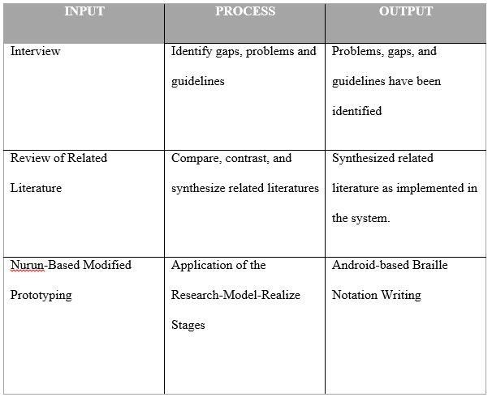

*Figure 1.* Conceptual Framework of pinDOTS

# Input

A set of questionnaires was composed for the interview used on the data gathering process. According to Masongsong (n.d.), SPED teacher in CES or Carmona Elem School, three visually impaired students are enrolled in SPED class with only 1 teacher that guides them. They only use slate and stylus, and braille writer and other instruments and modules in teaching braille. The review of related literature sets as guide that determines the current existing research and fill the gaps in related to the study. The Nurun Methodology is a modified prototyping method intended for the development of Internet of things projects.

# Process

Identifying gaps and problems would allow the study to be able to focus on the real and main issues resulting to accurate providing of solution or help to enhance the beneficiary’s present situation. Comparing, contrasting, and synthesizing related literatures are used to support and verify the study’s different statements. It is also used as a medium to gather new information that can open up ideas which may be used to further improve the study.

# Output

The study is expecting to provide solutions on handling the gaps and problems. The researches from the related literature must state claims that are verified and legitimate to identify further improvement by synthesizing the researched study and lastly, the study is expecting to create an assistive technology that will aid visually impaired students in learning how to write elementary braille notation.

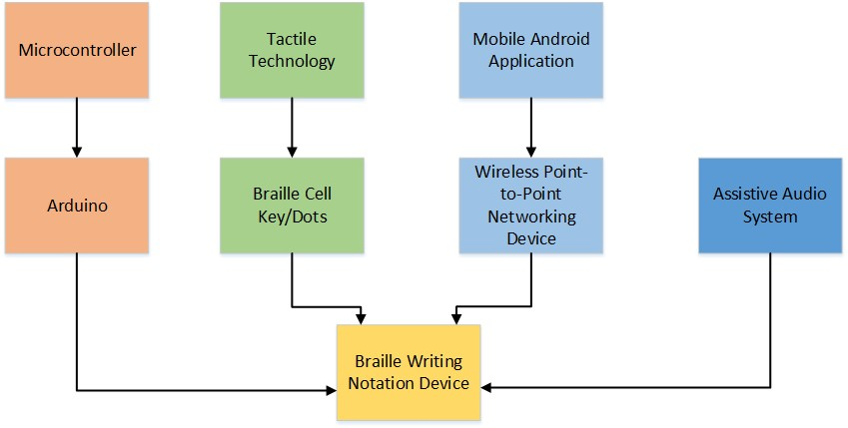

## *Figure 2.* Conceptual Model of pinDOTS

The developers considered technical concepts that can help in realizing the objectives of the study. Primarily, the use of a dedicated microcontroller that is low cost and readily available will be included in the study. In this study, Arduino will be used as the core microcontroller. In order to provide the mechanism that will allow visually impaired students to perform actual writing, the developers will be improvising a tactile technology that can be engraved and embossed by manually pressing buttons/switches to produce a notation symbol. Concepts and standards in terms of braille notation will be incorporated in the braille cells of the device. To commence communication between the device and the Mobile Application, the concept of Wireless Point to Point networking will be utilized. This concept shall allow data to be transferred to the braille device when performing drills and notation writing activities.

**Scope and Limitation**

# Android Application (SPED Teacher)

An android application will be developed that can be used by SPED teachers. The application will facilitate pre-defined words which can be used to create user – defined drills. Once a drill is created, the SPED teacher will be sending the drill to the device using a point to point networked connection using a programmable WiFi module. This connection will be facilitated by WEMOS WIFI Module. Once the user will send the drill it will be stored in a PC Server and ARDUINO will fetch the drill through WEMOS.

# Braille Device (Visually Impaired Student)

The braille notation device hardware would be a compact and scaled single character braille cell device. It has 6 keys in form of switch/button and dots in form of tactile technology using Solenoid. The braille device is based on notation format that can be embossed or engraved by pressing assigned buttons/switches to produce a braille notation character. An assistive audio system will be embedded in the device that would guide the visually impaired students in using the braille notation device. For testing purposes, only one device will be provided by this study.

The different modes consist of Tutorial Mode and the Drill mode.

**Tutorial Mode:**

The tutorial mode is for the beginners that would let the students learn the position of the switches and the braille dots of our braille device by giving a step by step instruction with the use of the assistive audio system. After pressing a button, the students will be given 10 seconds to feel the designated dot (*for example: if the first button is pressed the first dot will be embossed/engraved)*. After the student, will be able to learn the position of all switches/buttons and dots of the braille device, the students will be able to explore the braille alphabet notations freely by pressing the switches/buttons. The tutorial mode will be the default mode upon starting the braille device.

**Drill Mode:**

In the drill mode, the students will be given 3-character words facilitated by the android application in a point to point network environment. The student will be writing each character one at a time. The students will be given instructions by the assistive audio system.

For the limitations, there will be no notation for the numbers. There will be no more than three-letter words to be spelled for the Drill mode. There will be no online server, only point to point communication. There will be no contracted words for the braille device.

**REVIEW OF RELATED LITERATURE**

# The Need for Braille

The society has become increasingly alarmed in recent years about the growing illiteracy rate among our children and young adults. This increase is occurring, of course, at the very time in our nation’s economic life when the need for true literacy is increasing. For blind people improved braille literacy has been the focus. It has always seemed self-evident that our chance for success that increases in direct proportion to our ability to read and write effectively. However, while our common sense has told us that blind people must master braille to success, supposed common sense has also told many in the field of special education that such skills are not important for the blind and that tapes or computers or large print of magnification devices can be as just effective as rather than reading and writing braille. (Ryles, 1996)

There is no substitute for the ability to write or read. For blind people, braille is an essential tool that aids in the process of becoming literate. Tape recorders and synthesized speech are useful tools, but they are inadequate substitutes for reading and writing. Braille literacy plays the same key role in a blind person’s life that print literacy does in a sighted person’s, which increases opportunities.

Learning to read and write can be challenging, and in every situation, takes time and practice. It takes the support and encouragement of family and teachers. This is true for individuals with or without vision loss. Braille doesn’t have to be difficult to learn, especially if the student is young. Therefore, it is never too early to begin teaching someone braille. Learning braille early supplies the individual with more options. (“The Importance of Braille”, 2014).

# Braille Notation

Braille has been the primary reading medium for persons who are blind or severely visually impaired for many years, since Louis Braille perfected the braille code in 1834 (Hatlen, 2000). Braille characters are formed from 63 various combinations of six dots arranged three high and two wide in a cell-like pattern. Now braille can be used for writing text, music also technical material for math and science. There are two primary forms of braille, uncontracted and contracted. Uncontracted braille, previously referred to as alphabetic or grade 1 braille, consists of the alphabet plus punctuation and “literary” numbers. Contracted braille or standard braille, was previously called grade 2 braille, consists of alphabet, punctuation, plus various part and whole word contractions. This expands the number of basic symbols to be learned for reading literary material. It has been approved code for reading and writing braille in the United States. It is generally assumed that being able to read and write braille literacy, since most books and magazines use this form of code. (Wormsley, 2004)

# State of Visually Impaired Students in the Philippines

Visually impaired students in Philippines as according to (De Vera, 2015) has not been able to have quality education because of limited access to assistive devices and lack of facilities that can provide the appropriate learning style for children with disabilities (De Vera, 2015, September). Based on the 2010 Census of Population and Housing, 92.1 million is the total population of the country in which 1.443 million are Person with Disabilities (PWDs) or 1.57%. And 20,171,800 are Children with Disabilities (CWDs) or those children who are with hearing, visual, mobility, intellectual and speech or language impairment, serious emotional disturbance, autism, and special health conditions, specifically aged 5-14 years old. These numbers of CWDs is expected to increase up to 23,012,400 by the year 2030, this shows that even a small increase is still a significant factor in the society and alarming for the nation. (NASO, 2014)

SPED early enrolment in government elementary schools shows that there were 40,181 CWDs students enrolled in the Philippines in 2012. Of this number, 4,925 are visually impaired students, 509 of them are from CALABARZON (De Vera, 2015). The following year shows a significant increase of CWDs students enrolled in government schools, the numbers indicates that there were 110,169 students including kindergarten. 15% of those students were from SPED class mainstreamed in regular classes while the remaining 85% of the students are those who have no experience in attending any SPED classes. On the other hand, in secondary level there were 84,232 students with disability were enrolled in government schools. (Philippine Education for All 2015 Review Report, 2015)

# Braille Notation for the Beginners

Beginner is defined as a person just starting to learn or take part writing or reading braille notation, it can also be a person who are making the transition from using print to braille. Young children have short attention spans, perhaps especially for the more structured, seated tasks of braille literacy. Physically, it takes time to learn to maintain correct reading and writing posture and hand/finger positioning, to tolerate the sensation of running their fingers over braille lines, and to strengthen each finger, especially for pressing the keys for dots three and six. It also takes time for children to build up speed in reading writing, especially with the letters with more dots.

Accordingly, braille writing instruction might begin with just five or ten-minute lessons and expectations of just a few lines of braille. (In braille writing, the margin might even be set in the middle of the page, so that each line is shorter.) As lessons progress, lessons become longer and longer and expectations for strength and stamina increase. Sometimes children maintain their attention in braille, and sustain more arm and finger strength, when they stand (rather than sit) at a table or desk as they read and write braille. In any instance, the pages or keys should be at elbow level or even slightly lower. Braille reading and braille writing are quite separate processes. First, they are based upon different sensory systems. Braille reading is tactile and motoric; dots are felt through the touch receptors in the fingertips as they move across lines. Braille writing is kinesthetics/proprioceptive and motoric; dots are formed by moving the fingers to press specific keys, and braille writing is mastered by memorizing how the joints in the fingers feel as specific keys are pressed. (Hudson, n.d.)

# Standards

The braille alphabet is based upon a "cell" that is composed of 6 or 8 dots, arranged in two columns of 3 or 4 dots each. Each braille letter of the alphabet or other symbol, such as a comma, is formed by using one or more of the dots that are contained in the braille cell. (The letter "a" is pictured below.)

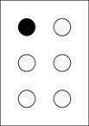

The following chart provides a good example of the design of the braille alphabet.

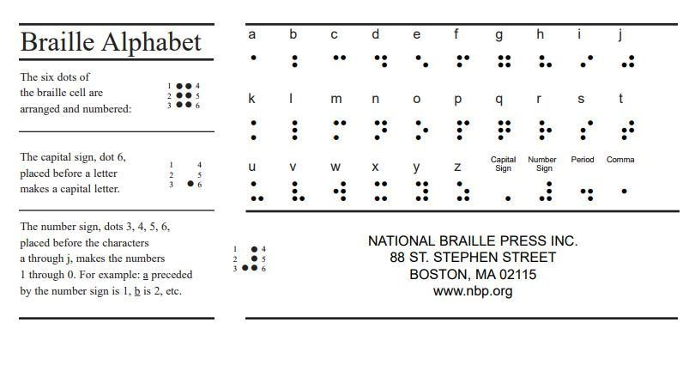

## *Figure 3*. Braille Alphabet

Each real braille-delivering nation has standards for the size and spacing of braille embossed on paper. For example, in the United States and Canada, Section 3.2 of Specification 800 (Braille Books and Pamphlets) February 2008 is the standard dimension of braille embossed on paper. However, there are no specific size and spacing for assistive technology for visually impaired. [(“Size and Spacing of Braille Characters”, n.d.)](http://www.brailleauthority.org/sizespacingofbraille/sizespacingofbraille.pdf)

Summary of Section 3.2 of Specification 800 (Braille Books and Pamphlets) February 2008 is given below:

The suggested height of braille dots shall be 0.48 mm, diameter of braille dots shall be 1.44 mm. As for cell spacing the suggested distance from center to center of adjacent dots (horizontally or vertically) in the same cell shall be 2.340 mm, distance from center to center of corresponding dots in adjacent cell shall be 6.2 mm. The nominal line spacing of braille cells from center to center of nearest corresponding dots in adjacent lines shall be 1.000 cm. (“Accessible and Usable Building and Facilities”, 2003)

However, aside from the standard printed tactile braille notations there are of braille materials can have different scale or design built to aid visually impaired students. According to Tebo (n.d.), printing larger braille dice is useful for better number recognition that serves as a better way of learning math concepts. Enlargement of braille graphs, maps, and chart or also known as Tactile Graphics is considered to allow person with visual impairment to convey non-textual information easier. These braille designs is to ensure that students with visual impairment have the tools necessary to fully access and participate in the curriculum, with the greatest possible level of independence. Also, Jumbo braille is also used for visually impaired people who are having trouble in distinguishing the dots of a standard braille size. (“Tennessee Council of the Blind”, 2008)

**Current Braille Display Technologies**

Basically, all sold refreshable braille displays are developed from single-cell braille modules of 6 dots in two columns of 4 dots. Almost all braille modules accessible today utilize piezoelectric ceramic bimorph reeds to actuate the braille dots. Every reed can lift the dome top of its 1.5mm diameter braille pin approximately 0.5mm over the reading surface. Check Appendix A for a typical module has 4 layers of side-by-side pairs of reeds mounted horizontally, below and parallel to, the top reading surface. Appendix A also shows the associated data latch and 200V driver circuitry required for, and integrated into, each braille cell module.

These modules are horizontally mounted next to each other in arbitrarily long lines (typically 20, 40, or 80 cells). It is possible to mount two of these lines together for a two-line display, but packaging size and cost limit most displays to a single line.

**Recommendation for Braille Technology**

*Deputy Librarian of Congress Robert J. Dizard Jr.* released a report exploringissues related to braille, the literacy tool that makes independence possible for people who cannot see to read regular print, at the National Federation of the Blind national convention in Orlando, Florida. Panels discussed improvements in the braille code, methods of producing braille, lowering costs, leveraging technology, and addressing misperceptions about the literacy tool. Other stakeholders were encouraged to address the shortage of teachers and cost prohibitions, make better use of technology to reduce the cost of braille production and to produce a low-cost braille technology. (Osterberg, 2014)

According to “Texas School for the Blind and Visually Impaired”, assistive technology can only improve basic skills of visually impaired students. It should be used as part of the education process and is a fundamental work tool for visually impaired students. (“Principles of Assistive Technology for Students with Visual Impairments”, *n.d.*)

According to a research by Tebo (2012) large print/braille dice is better. It can be useful in terms of number recognition and various types of math games. It can be useful in terms of teaching or telling time as well. Large print / braille Bingo Cards can teach visually impaired students to scan numbers instantly while emphasizing concepts of horizontal, vertical and diagonal. Hardware’s with large print can provide sufficient supports to visually impaired students.

# Assistive Technology for Students who are Visually Impaired and Blind People

Any adaptive device, software program or product system that used to increase cooperation, accomplishment, or improve the functional capabilities for a student with a disability is considered as Assistive Technology.

In the Philippines, the government provides conventional methods of producing braille material that are simply not adequate to meet the needs of the blind Filipino readers. In Philippine Braille Technology Center, the institution only provides Braille Bible, Braille Magazines, and Braille Textbooks. Computer technology is providing the solution to this problem. By encoding the text into a computer file, and by using small, computer driven braille embossers, many copies can be quickly produced. The institution is using the latest technology to produce up to one million pages of braille per year.

Assistive Technology advances to a quick pace, requiring ongoing research and awareness on the part of the practitioner. The reader will find a list of low- and high-technology devices that offer students access to the academic curriculum as well as extra-curricular activities. In spite of the fact that the focus of this data is on helping students who are visually impaired or have low vision, these tools may likewise be useful for some students with other disabilities. It is essential to understand the need of instructing the basic aptitudes should have been autonomous in the utilization of assistive innovation, which can be similarly important in classrooms and group. For instance, braille note takers are valuable not just for note taking in class, additionally to compose and printing articles, composing notes, send emails/messages, or browsing the Web. (Wiazowski, 2009).

Students with visual impairments will require various types of operating system accessibilities to do computer-based assignments. For some, built-in accessibility features will suffice, while others will need full-fledged specialized software. Students should participate in an expanded core curriculum that includes the use of compensatory skills, orientation and mobility, social interaction skills, independent living and personal management skills, recreation and leisure skills, career and vocational education, visual efficiency and need for/use in Assistive technology. Compensatory skills include the use of tools, adaptations, modifications and behaviors that maximize the student’s opportunity to access the environment, educational activities information and basic human needs. This can include a variety of communication tools, adapted reading and writing, organizational and counting tools. (Wiazowski, 2009).

The current challenge is to provide appropriate access to and instruction on blindness and low vision specific assistive technology through individualized assessment of assistive technology needs, appropriate instruction in the use of assistive technology as tools, and equitable distribution of assistive technology. (Smith et al., 2011). Currently, some students with visual impairments have access to a wide range of blindness and low vision specific assistive technology devices, while others have none at all (Kelly, 2008).

The reported work advances the state-of-the-art in assistive technology for the blind by enhancing a low-cost automated tutor designed to teach braille writing skills to visually impaired children using voice feedback.

**Existing Products**

**Braille Notetakers**

Braille Notetakers are personal digital assistants for individuals who are blind or visually impaired. Input is through a Perkins-style braille keyboard or a standard QWERTY keyboard.

Output is through an adjustable speech synthesizer and some models include refreshable braille displays which can also provide refreshable braille when connected to a computer running popular screen reading programs. Check Appendix B for different types of braille technologies.

**Taptilo: New Smart Device to Teach Braille**

TAPTILO is an innovative braille education machine to solve insufficiency of braille-trained teachers and to improve a quality of braille education in developing world. It is a smart educational machine that helps students learn braille easily and fun even if they do not have a professional teacher. Firstly, students are able to check the spelling, and progress through the app by themselves including hundreds of vocabularies. This ensures that learning is not delayed when students are unable to attend school or study at home in vulnerable areas. Secondly, tutors just need a short training to teach braille and tutors can teach a number of students at the same time in the classroom. This will help overcoming the lack of braille-trained teachers in marginalized area. Finally, students can easily learn braille without losing interest because TAPTILO offers 5 difference self-study modes including game and sound feedback. It enhances students' learning effectiveness and their ability to learn independently. (Yun,2017).

See *appendix j* for TAPTILO device.

**Current Research and Projects for Braille Notation Writing**

**Flight**

Reading printed documents and writing paper pose a great challenge for visually-impaired people. Existing studies that attempts to solve these challenges are expensive and not feasible in low-income context. Flight is a low-cost reading and writing system for economically less privileged people. It uses ink-based braille characters as the medium of textual representation.

Flight utilizes a low-cost wearable device to enhance ease of reading by visually-impaired people. (Chakraborty, Khan, & Al Islam, 2017)

**Electronic braille typing interface**

A user interface system for entry of braille input to electronic devices comprises a module with a single set of six tactile keys arranged in a 6 dot braille configuration. The user interface system is configured to recognize data entered therein by user contact with one or more of the tactile keys as braille input and to transmit said braille input to an electronic device for display or further transmission. The interface further includes function keys which allow the user to manipulate, modify, or otherwise control the data entered and how the data is transmitted (Morgan, 2013)

**Current Existing Technology/Study for Teaching Braille Notation**

According to (“Patent US4880384 - Braille Teaching Apparatus.”, 1989), the present invention provides the construction of a number of blocks, each containing the appropriate dot arrangement on its surface to represent a braille character, sound, word, or number. The braille blocks are similar in construction to a two by three matrix Lego™ brand building block. However, the two by three matrix of dots is altered such that the dots on a block are representative of a braille character. The present invention also involves the structure of a rigid board upon which the braille blocks may be affixed. This board allows for the creation of words and sentences upon its surface. The board also prevents the inadvertent jumbling of the blocks placed upon it such that a tutorial lesson is not interrupted by any disturbances. This feature is particularly important when one is teaching the young or the retarded to read braille.

According to (“Dotty:Braille Learning Aids”,n.d), Dotty is an independent development designed entirely by PEGA D&E. Unlike most of the IT products on the market, Dotty serves a different purpose and a specific market; Dotty is made to assist the visually impaired to learn braille in an easier and faster way. Dotty assists the visually impaired in their pre-school period or anyone who is new to braille; in a general sense, Dotty shortens the gap between the visually impaired and technology.

According to (Cooper & Nichols, 2007), young children who are visually impaired often do not have braille books and materials at home or in a child care environment in the same quantity and quality as print materials. Because of this lack of exposure to braille, many of these children begin their education with a significant disadvantage compared to their peers who are print readers.

# Functionality Testing

# Functionality testing is a type of testing that is used to test the features of the hardware or software. Functionality testing will be used on the hardware and software to ensure that the product performs as expected and documented. It can be performed on hardware or software products to verify that your product functions as designed.

# The general purpose of hardware and software functionality testing is to verify if the product performs as expected and documented, typically in technical or functional specifications (“Functionality Testing”, 2015)

# Assistive Audio in Developing Assistive Technology for the Visually Impaired

# According to Willings (n.d), an audio or listening skill is one of the major source of information for visually impaired students. Once the student has developed basic auditory and listening skills, it will help them in deriving meaning from the sounds or convey information better through listening.

Audio help the students to understand, appreciate and open up literary texts. Most if not all of the blind benefits from assistive audio by allowing them to navigate through sections of whatever content they are exploring more efficiently. One example instructional audio that helps blind people to be able to use a specific device better and obtain more information. It also provides a way to examine the spelling of words and sentence construction of the recorded content. (“Even Gounds, Inc.”, 2013)

Assistive Audio can really help the visually impaired students to read and write and learn from audioassisted reading and the students may encourage to read \, write and learn more. With the help of audioassisted reading students might learn faster than the traditional reading/writing braille. Students explained that audio-assisted reading helped them to identify words and many expressed interest in continuing to use the books and audio recordings at home in second grade (Esteves, 2007)

Children with significant vision loss and blindness are at an increased risk of literacy problems relating to reading speed and accuracy (Coppins & Barlow-Brown, 2006; Steinman, LeJeune, & Kimbrough, 2006)

The poor reading achievement of students with visual impairments and the life-long consequences of low literacy make it imperative that Teachers of the Visually Impaired (TVIs) use braille teaching practices that have a demonstrated record of success (Stanfa and Johnson, 2015).

**Technical Hardware and Technologies in Developing Assistive Device**

* **Arduino**

Arduino will be used as the micro controller for the device. Arduino is an opensource electronics platform based on easy-to-use hardware and software. Arduino boards are able to read inputs - light on a sensor, a finger on a button, or a Twitter message - and turn it into an output - activating a motor, turning on an LED, publishing something online. You can tell your board what to do by sending a set of instructions to the microcontroller on the board. To do so you use the Arduino programming language (based on Wiring), and the Arduino Software (IDE), based on Processing. (“What is Arduino?”, n.d.)

According to (“Varesano.net”, n.d.) Arduino is accessible and flexible to be customized and extended. It offers different types of digital and analog inputs, SPI and serial interface and digital and PWM outputs.

* **Tactile Material**

Tactile material is intended to be read by touching the dots. According to (“Loomis and Lederman”, n.d.) there is a useful overview of the three aspects of interpreting information through touch that could be referred to collectively as *tactual perception*. They state that there are two fundamental and distinct senses that together provide us with a sense of touch: the cutaneous sense and kinesthesis. The cutaneous sense provides an awareness of the stimulation of the receptors within the skin, whereas the kinesthetics sense provides an awareness of the relative positioning of the body (head, torso, limbs etc.). Perception that involves one or more of these can be regarded as *tactual perception* and there are, therefore, three forms of such perception. The tactilematerial with be non-metallic button/switches.

Tactile perception is solely dependent upon variations in cutaneous stimulation by such actions as tracing a pattern upon an individual's skin. Tactile perception alone means that the individual in question must be static; otherwise the kinesthetics sense will be incorporated.

Kinesthetics perception is concerned with variations in kinesthetics stimulation. However, tactual perception without contribution from the cutaneous sense can only really be achieved under contrived circumstances such as using anaesthetic to suppress the cutaneous contribution.

* **Audio System**

Audio system is a system of electronic equipment for recording or reproducing sound. The prototype gives a 100% correct result for the write mode by identifying if the correct braille combination entered by the user is correct or incorrect through an audio message. (Arro et. al., 2016)

# Wireless Point-to-Point Device Network

# Point to point wireless is a networking technique for linking or connecting to physical networking devices with the help of wireless technology (“What is Point-to-Point wireless network”, 2015). For the two devices to communicate with each other, a point-to-point communication must be enabled to do so.

# Saxena et.al (2009) discusses how developing authentication technologies can be very suitable for the blind or visually impaired. In their study, the focus is on two technologies: user authentication, i.e., how a blind user can securely authenticate to a device (remote or otherwise) and device authentication, i.e., how a blind user can securely establish private and authenticated communication between two wireless devices. Medium- and short-range wireless communication – based on technologies such as Bluetooth and Wi-Fi was considered in the said study. This could be also very helpful to this study since the project is also expected to be held in a similar network environment.

# Guidelines for Assistive Technology for Visually Impaired People

Assistive Technology is defined as any product, equipment, and software programs that help people with disabilities including visually impaired people to increase, maintain, and improve their functional capabilities. (“Assistive Technology Industry Association”, 2017)

Assistive Technology can only enhance students’ basic skills not replace them, it serves as an important tool in educational process. For visually impaired students, these assistive technologies are more than an educational tool. It is a Fundamental Work Tool, is serves as their pen and paper allowing them to complete educational tasks and participate on class as well. Every visually impaired student needs are unique and should be matched with necessary tools or technology, instead of matching the existing technology to the student needs. Functional use of these assistive technologies requires redundant sensory feedback. With this, it enables visually impaired students to maximize their communication rate and improve their literacy. (“Texas School for the Blind and Visually Impaired”, n.d)

A study by Kapperman, Smith, and Kelly states that there is no specific solution for access to appropriate assistive technology that is suitable to address the specific needs of every person with visual impairment. Even students with same visual loss may require different specification or type of assistive technology that is based on their distinct needs. (Kapperman et al, 2011)

According to the Tennessee Council of the Blind (2008), grade 1 braille are normally used by visually impaired people who are new to learning braille notation. Grade 1 braille represent only one letter, number, and punctuation sign. Hudson also mentioned that students with visual impairments should integrate reading by a few characters. With this, it allows students to have an advanced literacy process (Hudson, n.d). Also, in a Text Module of TEXAS Department of Assistive and Rehabilitative Services entitled: *“Best Practices and Strategies for Braille Training”,* the curriculum guides schools and teachers to teach visually impaired students who are unfamiliar in braille notation reading and writing by emphasizing with activities for writing that recognizes 1 character to 3-character words.

# METHODOLOGY

This chapter will discuss the methodology to be used on developing the system for Carmona Elementary SPED School. This chapter will elucidate the methodology to be used and why it will be the best method to be used in this research.

# Nurun-Based Modified Prototyping

A modified prototyping method intended for the development of Internet of things projects. The methodology has three stages: Research, Develop, and Realize.

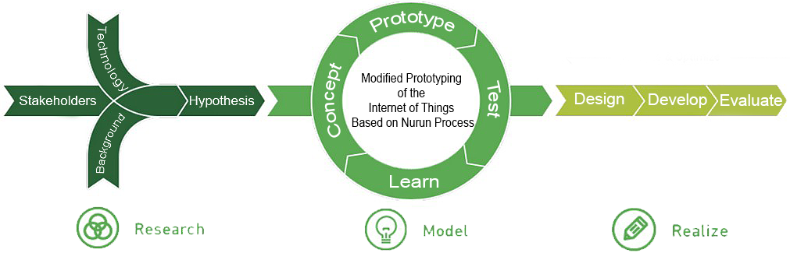

## *Figure 5.* Nurun-Based Methodology for IoT

**Research.** In this stage, the developers will gather studies and other related literaturesregarding the topic presented.

**Model.** In this stage the developers will create a working model, perform functionalitytest, and analyze for further improvements. This procedure will be repeated a few times until the system is completely developed.

**Realize.** In this stage, the respondents will be requested to test the system and evaluatethe system through a score sheet formulated by the developers.

# Research Design

The purpose of this study is to develop a low-cost electronic braille cells keying device on writing notation that will support assistive technology for the visually impaired students in SPED schools. Initially, the developers performed data gathering through an interview using a survey. The survey was utilized to gather information which will be needed for the development of the device. This was followed by a Functionality Testing. Following the Nurun Methodology, functionality testing will be performed by the developers. Functionality will provide a set or list of functionalities and will be scored and rated by the developers. The last phase of the research design will be User Acceptance Testing (UAT). In this test, the developed device will be delivered to the students and teachers of Carmona Elementary SPED School to determine software and hardware objectives were met.

The developers will be using a quantitative technique to gather data. According to (Babbie,2010), Quantitative methods emphasize objective measurements and the statistical, mathematical, or numerical analysis of data collected through polls, questionnaires, and surveys, or by manipulating pre-existing statistical data using computational techniques. Quantitative research focuses on gathering numerical data and generalizing it across groups of people or to explain a particular phenomenon. The goal of conducting a quantitative research is to define the relations between one thing and another within a population. It aims to classify features, count them, and construct statistical models in an attempt to explain what is observed.

# Research Locale

The study will be conducted at Carmona Elementary School, specifically in the SPED Center where the visually impaired students are catered. Carmona Elementary School is a DepEd managed public school located in Barangay 8, Carmona Cavite. The said locale is open to studies and researches intended to development of assistive learning technologies that would benefit visually impaired students.

# Population of the Study

The study will be focused on the students of Carmona Elementary SPED School. There are three visually impaired students who are enrolled in SPED class with 1 SPED teacher available to guide them. The three visually impaired students are Level 1 in braille or beginners, according to the SPED Teacher. One with refracted vision, another one acquired from glaucoma and now totally blind and one who is in-born blind. The SPED teacher is also the expert and the lead trainer of SPED Teachers in CALABARZON area. According also to Ms Manongsong, all three students are exactly three different types of visually impaired cases. Basically, Carmona SPED is able to cater different types of cases.

All of these visually impaired students can be used in the study since the target of the device are visually impaired students who are beginners or have no prior knowledge about braille notations. Given that the research locale only has three students and one teachers, the developers will be using the Total Population Sampling. Total population sampling is a type of sampling that involves the entire population with a particular set of characteristics. Thus, allowing all the four, including the SPED teacher to be part of the study.

**Data Gathering Tool**

The tools that will be used to gather data are as follows:

# Interview

For this study, the developers gathered data through an interview using a survey. Using this method, the developers has formulated a predetermined set questions given to the respondents. This method was used to quickly gain information about the population and use this information to identify the needs and requirement for the study.

# Functionality Testing

Functionality testing is the phase of the where the developers will test the hardware and software. Functionality testing will be used to verify if the prototype’s functions are met. The test will have a set or a list of functionalities which will be rated Passed or Failed for each iteration of test performed. Through this method, the developers will be able to analyze the data gathered and be informed of what improvements are needed for the hardware and software for it to function better. This shall happen accordingly base on the given methodology.

# User Acceptance Testing

User acceptance testing (UAT) will be the last phase of hardware and software testing process. UAT is one of the final and critical software project procedures that must occur before newly developed software is rolled out to the target locale. (Setter, *n.d.*)

The User Acceptance Test will be conducted by the identified respondents after the development of the prototype following the methodology. In this test, a UAT instrument will be used to gather feedbacks from the respondents and use these data to determine if the objectives of the study were met and also determine the feedbacks that can be used for improvement and recommendations.

# Data Gathering Procedures

The following are the procedures for the gathering of data:

1. **Conduct Interview**- The developers conducted interviews to selected key respondents of the chosen locale, Carmona Elementary School SPED Center. Questions are given to the respondent and answers were collected and recorded to identify important problems, requirements and the need for the project.

1. **Conduct Functionality Test**- The developers will be testing the developed device using the functionality testing. During this phase, the developers will be rating the functionalities of the prototype per module and collect the data to verify if the prototype’s functions are attained. Functionality testing is necessary with the chosen methodology for the developers to create a better working prototype during the development stage of Nurun-based modified prototyping, the testing of the hardware and software will be done repeatedly by the developers and do so until the hardware and software are complete.

1. **Conduct UAT-** After the functionality testing of the prototype, therespondents will be testing the prototype developed to ensure that the device can handle the tasks of the users. UAT will be utilized to evaluate the prototype to gain feedback that can be considered in improving the device or use for recommendations. The UAT will also help identify whether the objectives set by the study are met.

In order for the visually impaired students to answer the UAT, the set of questionnaires was provided to the SPED Teacher. SPED Teacher, being the expert in dealing with visually impaired students, facilitated the UAT by dictating questions. Dedicated answer sheet made through a braille printer was also given to allow students set ratings for each of the given items in UAT. After answering the UAT, the SPED teacher collected results and provided a file containing the results to the developers.

# Data Analysis Plan

The developers interviewed the Carmona Elementary School SPED teacher. With proper analysis of the gathered data, the developers identified the problems which particularly are the high-cost of available assistive technology in braille notation writing for visually impaired students, limited features in assistive technologies that are tailored to visually impaired students who are unfamiliar with the basic braille notations and lack of interactive modules emphasizing on kinesthetic and motor skills like touching and pressing in SPED Center that can be used prior to formal braille writing.

In the model stage, functionality testing is going to be conducted iteratively to test the functionalities of the android application and the device until the final output is achieved. As the developers are testing the system, checklists are going to be used to constantly monitor the progress of the development of the functionalities of the system by rating the each of the system’s modules. For this test, the rating will be in form of Passed or Failed which will be recorded and tabulated for every test done iteratively.

A User Acceptance Testing is going to be conducted in the realize stage. Using a four-point

Likert Scale the developers aim to identify the respondents’ opinion to the prototype’s performance for the developers to know what to improve or what to change in the development of the system. The functionality of the device and android application will be evaluated where SPED teachers will evaluate both the device and android application and visually impaired students will evaluate only the device. The testers will be given four options where a rating of 1 is the lowest and a rating of 4 is the highest.

The developers will acquire the results of the evaluation done by the SPED teachers and visually impaired students of CES by calculating the averages of the ratings from the 4-point Likert Scale for both the alternative assistive learning device and android application. The following steps towards the improvement of the prototype are going to be based on the evaluation results.

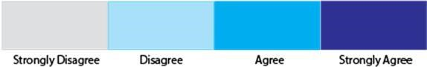

*Figure* Point Likert Scale Interpretation

# Results and Discussion

The study conducted an evaluation and tests for mobile application and the braille device. For the braille device, visually impaired students took part in testing and mobile application tests were performed by the SPED teacher expert. Tests were conducted at Carmona Elementary

School located in Carmona on March 12, 2017.

# Functionality Testing

Table 1-5 shows the results of the Functionality testing. During the development of the application and the hardware device, a weekly testing is performed. The application has 5 modules to be developed which are all listed in the checklist with its current status. In the span of five weeks, all the modules of the application are functional and only needs design improvement.

# Modules: Audio System

Table 1 shows the number of testing done and what was done during the functionality test of the Audio System. The developers started to convert the audio to a specific format because as per the developer’s research, there is a specific file format for the SD Card Module to read and play. After the first test, the audio was not able to play thus having a failed result. In the second test, the developers tried to research what the specific file format and conversion settings is. After extensive research, the developers found an information that states that the Audio must be in 8-bit resolution, 16000 Hz sampling rate, and also in mono audio channel. The audio managed to play and it was a success, but the developers found that the audio was not clear enough thus converting the audio once more. The developers tried to increase the sampling rate to 32000 Hz and the sound was a little bit unclear than the second test. The developers tried to decrease the sampling rate to 11025 Hz and the sound was clearer than the past tests.

|  |  |  |  |  |
| --- | --- | --- | --- | --- |
| Test No. | Test Procedures | Materials/Data | Results | Remarks |
| 1 | Converted Audio format to WAV  file | Audio File | Unsuccessful;  Audio file did not play from SD Card Module | Failed |
| 2 | Converted Audio file to WAV file with 8-bit  resolution, 16000  Hz sampling rate, and mono audio channel | Audio File | Successful;  Audio File played in SD Card  Module | Passed; Audio played but the sound  is not clear enough |
| 3 | Converted Audio file to WAV file with 8-bit  resolution, 32000  Hz sampling rate, and mono audio channel | Audio File | Successful;  Audio File played in SD Card  Module | Passed; Audio played but the sound  is worse than the 16000 |
| 4 | Converted Audio file to WAV file with 8-bit  resolution, 11025  Hz sampling rate, and mono audio channel | Audio File | Successful;  Audio File played in SD Card  Module | Passed;  Audio Played and sound is better |

*Table 1.* Functionality test of the Audio System modules.

# Module: Wemos

Table 2 shows the procedures done by the developers for developing the module which needed to pass data from the mobile application to the device using wemos. The developers succeed at test no.2 when the wemos was set to a common ground between Arduino and wemos and reducing its baud rate from 115200 to 9600 in order to pass the data in form of string unlike for the first test which failed using higher baud rate.

|  |  |  |  |  |
| --- | --- | --- | --- | --- |
| Test No. | Test Procedures | Materials/Data | Results | Remarks |
| 1 | Sending of data from Wemos to  Arduino | Wemos Arduino  Connecting wires Sending | Unsuccessful;  Sending garbage data | Failed |
| 2 | Set a common ground for  Wemos and  Arduino and reduce baud rate of Arduino to Wemos from  115200 to 9600 | Wemos Arduino Connecting wires | Successful;  The data in form of string has been  successfully transmitted | Passed; |

*Table 2.* Functionality test of the Wemos modules.

# Module: Mobile Application

Table 3 shows the tests done by the developers in the development of the mobile application. The first test done by the developers is to read from the database and the developers were successful with the test. After reading from the database, the developers tried to insert the read data into the spinner, there were times that the developers received errors but managed to make it work at the end. Populating the android list view took a lot of test but still managed to make the test work and stuck with it. Creation of drills was an easy task and the developers managed to store the created drills to the database with ease. After creating the drill, the developers added an update and delete module for the user to make the management of drill more convenient. Then, the developers added additional features that can help the teacher practice writing braille notations.

|  |  |  |  |  |
| --- | --- | --- | --- | --- |
| Test No. | Test Procedures | Materials/Data | Results | Remarks |
| 1 | Reading data from database | Data in form of String | Successful; Word successfully  fetched from database | Passed |
| 2 | Inserting read data unto android Spinner | Data in form of String | Successful;  Android spinner populated with  words from database | Passed |
| 3 | Populate android list view with  words from database | Data in form of String  Array of String | Successful;  List View populated with  words from  database | Passed |
| 4 | Creation of Drills | Data in form of String  Array of String | Successful;  Drills created with words from database | Passed |
| 5 | Drill words manipulation | Data in form of  String | Successful;  Added and Deleted words in creating Drills | Passed |
| 6 | Manipulation of Created Drills | Data in form of  String | Successful;  Sent created drills to braille device and Deleted created Drills. | Passed |
| 7 | Added additional features like  Reference and  Braille Emulator for Teacher | Data in form of  String | Successful;  Successfully added additional features  to assist the user in braille notations | Passed |

*Table 3.* Functionality test of the Mobile Application.

# Module: Braille Dots

Table 4 shows the tests done by the developers in the development of the braille dots. The developers were able to succeed at test no.4 using solenoids for engraving and embossing instead of improvised dot which the materials used was relay witch with pins attached to its top and it failed because of inconsistency of power due to the connection of braille buttons. Solenoids used was consistent but needed separate power source in order to stable its connection.

|  |  |  |  |  |
| --- | --- | --- | --- | --- |
| Test No. | Test Procedures | Materials/Data | Results | Remarks |
| 1 | Use DIY solenoid | Wires, 6 small nail breadboard | Unsuccessful; lack of casing and  requires loop of wires. | Failed |
| 2 | Use relay | 5v power supply, 6 relay switches, breadboard,  connecting wires, resistors/capacitors | Unsuccessful; some relay switch did not run due to power source. | Failed; requires better embossing |
| 3 | Used solenoid connecting to  breadboard & Arduino. | 5v adapter, 6 solenoids, 6 relay module, 1 diode, wires. | Success, solenoid has individual  voltage separate to  Arduino for better power source. | Passed |

*Table 4.* Functionality test of the braille dots modules.

# Module: Braille Buttons

Table 5 shows the tests done by the developers in developing the braille dots. Test no.2 succeeded when the developers used 3pins switch instead of 2pins button because the 3 pins were able to separate the power, ground and input so the Arduino can distinguish it’s on and off state unlike the 2 pins the Arduino were confused whether it’s on or off. There were also no issue using switch instead of button according to our locale as long as the visually impaired students can distinguish the state of the switch if it’s on or off.

|  |  |  |  |  |
| --- | --- | --- | --- | --- |
| Test No. | Test Procedures | Materials/Data | Results | Remarks |
| 1 | Used 2 pins button for inputs of braille | Wires, 6 push button,  breadboard, 6 relays | Unsuccessful; relays can’t figure  out if the state is on or off | Failed; need to use 3 pins  button/switch for better input |
| 2 | Use 3 pins switch for inputs in  Arduino | Wires, 6 switches, breadboard, 6 relays | Successful;  3 pins switches worked properly with the solenoid | Passed |

*Table 5.* Functionality test of the braille buttons modules.

An alternative tactile technology is used to create a low-cost braille device. According to the SPED teacher in Carmona, the braille device the DEPED is targeting costs around ₱ 48,000 which limits the visually impaired students in learning and exploring their knowledge about braille. See appendix G for the list of products with corresponding prices. The materials that was used in making the improvised technology will be seen in Figure 6.

# Grand Total Table

# 

|  |  |  |  |
| --- | --- | --- | --- |
| **ITEM** | **PRICE** | **QUANTITY** | **TOTAL PRICE** |
| Solenoid | ₱ 392.00 | 6 | **₱** **2352.00** |
| Switch | ₱ 25.00 | 6 | **₱ 150.00** |
| Headphone Jack | ₱ 50.00 | 1 | **₱ 50.00** |
| Adapter Jack | ₱ 50.00 | 1 | **₱ 50.00** |
| 4pc Relay Module | ₱ 350.00 | 1 | **₱ 350.00** |
| 2pc Relay Module | ₱ 200.00 | 1 | **₱ 200.00** |
| Female header pins | ₱ 25.00 | 1 | **₱ 25.00** |
| Black Box | ₱ 105.00 | 2 | **₱ 210.00** |
| Connecting Wires | ₱ 8.00 | 73 | **₱ 584.00** |
| SD Card Adapter | ₱ 150.00 | 1 | **₱ 150.00** |
| Wemos D1 | ₱ 449.77 | 1 | **₱ 449.77** |
| Arduino | ₱ 850.00 | 1 | **₱ 850.00** |
| Breadboard | ₱ 120.00 | 2 | **₱ 240.00** |
| Speaker | ₱ 150.00 | 1 | **₱ 150.00** |
| Power Adapter | ₱ 270.00 | 1 | **₱ 270.00** |
| *Laptop | ₱ 7000.00 | 1 | **₱ 7000.00** |
|  | **GRAND TOTAL: ₱ 6,080.77** | |  |

*Table 6.* Tabular representation of materials used with corresponding prices.

*\*The grand total is excluding the price of the Laptop since in the locale there is already a pc for the use of the SPED Teacher. Including the price of the Laptop, Grand Total will be ₱ 13,080.77. The basis for not including the price of the laptop is, other devices mentioned in the table of Comparison of core functionalities that requires the use of PC/Laptop excludes the price of the*

*PC/Laptop.*

|  |  |  |  |  |  |  |  |
| --- | --- | --- | --- | --- | --- | --- | --- |
| Product(Price) | Engrave  & Emboss | 6 dots  Braille Cell | Wireless/Online  Connectivity | Keying &  Pressing | Multi  Character | Mobile  App | Assistive  Audio |
| pinDOTS  (₱5660.77) |  |  |  |  |  |  |  |
| Perkins Brailler  (₱41,470.01) |  |  |  |  |  |  |  |
| Electronic  Braille  Notetakers  (₱52,497.00₱787,455.00) |  |  |  |  |  |  |  |
| Taptilo  (₱62,996.40) |  |  |  |  |  |  |  |

*Table 7. Comparison of core functionalities of related braille writing devices*

The Table 7 shows the comparison of pinDots to the other braille writing device’s core functionalities. Electronic Braille Notetakers, with one of the lowest score in the table, shows that the Electronic Braille Notetakers and Perkins Brailler has no core functionalities that is appropriate for the beginners in learning braille notation. The other device which is TAPTILO has the most appropriate functionalities for the beginners of braille writing notation which is almost the same to pinDots. However, the cost of pinDots is notably lower than the said device. This result for pinDots as the practical choice as the device in teaching new visually impaired students about writing braille notation.

**User Acceptance Test**

# Profile of the respondents

The respondents that participated in the UAT are the teacher and the visually impaired students of Carmona Elementary School. There are 3 visually impaired students who tested the device and 1 expert SPED teacher who tested the mobile application. *See appendix N for the detailed profile of the respondents.*

# Evaluation Results and Interpretation

The UAT began by providing the teacher with an android phone with the application installed and providing the students with the braille device. The respondents were then given a short demonstration on how to use the mobile application and the braille device and were then told to test it. The results were then averaged to determine the final rating of the application and the braille device. The criterion used was 4-point Likert scale as mentioned in the Data Analysis Plan.

Figure 7. Shows the test results focused on Visual Aesthetics. The results indicated that the visually impaired students agreed that the device is easy to use and to recognize especially the characters for braille notation. The requirements needed for the device is achieved because the device should be portable, compact, and scaled. These were met with a rating of 3.8 average as the highest. They also agreed that the sizes are all equal because it is important for the visually impaired students, since the students can only feel based on the device. In Figure 7, the system got a final remark of “Agree” focusing on Aesthetics.

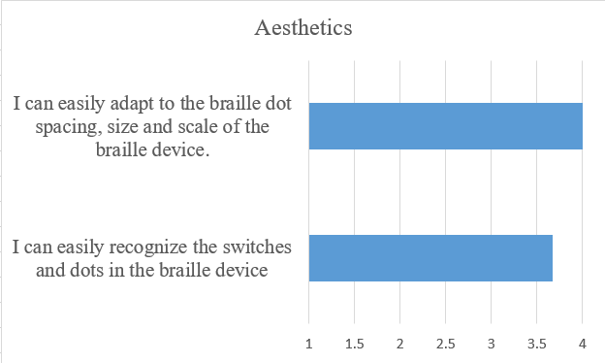

*Figure 7.* Visually impaired students Aesthetics Survey Results on braille device

Figure 8.1 and 8.2 represent the results focused on the aesthetic survey evaluated by the SPED teacher. The results showed that the design of the braille device was able to fit the requirements in notation learning. Also, the device’s spacing, size and scale is appropriate for the students to use. Also, the teacher agreed that the alternative assistive technology is appropriate and near the standards of some commercial braille devices. For the mobile application, the result show that the design of the mobile application is user friendly and the contents were understandable. The teacher’s aesthetic survey has an average rating of 3.7 for the braille device which has the remark of “Agree” and an average rating of 4 for the mobile application which has the remark of “Strongly Agree”.

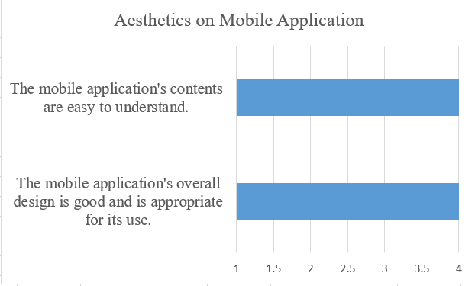

*Figure 8.1* SPED Teachers Aesthetics Survey Results on Mobile Application

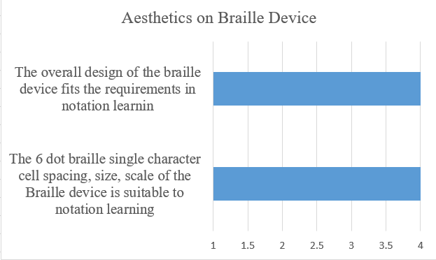

*Figure 8.2* SPED Teachers Aesthetics Survey Results on braille device

Figure 9 represents the results for the usability survey evaluated by the visually impaired students. The results showed that the students easily identified whether the dots are embossed or engraved. Also, it showed that they easily used the device despite using it for the first time. They can identify the braille dots with corresponding audio that gives instructions which is the main basis of using the braille device. The students’ usability survey has an average rating of 3.7 which has the remark of “Agree”.

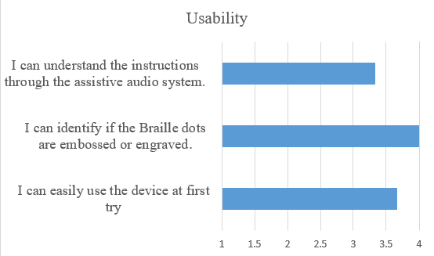

## 

## *Figure 9.* Visually impaired students Usability Survey Results

Figure 10 shows the test results on the capabilities of both the mobile application and braille device. The SPED teacher agreed that the mobile application is easy to understand even if it’s their first time to use it. Also, it is easy to navigate for the modules. For the braille device according to the result, shows that the braille device is highly portable enough, with the rating of 4 which has the remark of “Strongly Agree”. The SPED teacher usability survey has an average rating of 3.5 for the mobile application which has the remark of “Agree”.

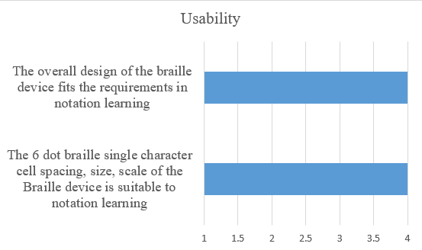

*Figure 10.* SPED Teacher Usability Survey Results

Figure 11 represents the usefulness survey evaluated by the visually impaired students. The results showed that the students easily familiarized themselves with the device. Also, it is easy to use especially the tutorial part of the device because of the effectiveness of the audio system thus the students can easily use it with minimal supervision of the teachers. Lastly, the students agreed that they can successfully write the characters as well as the words by using the braille device. The braille device also served as a good help in terms of practicing braille notation writing as well as pressing and keying skills. The students’ usefulness survey has an average rating of 3.9 which has the remark of “Agree”.

## 

## *Figure 11.* Visually impaired students Usefulness Survey Results

Figure 12 represents the results for the usefulness survey evaluated by the SPED teacher. The results showed that the teacher can easily change modes wirelessly through the mobile application. Also, the result showed that the teacher was able to create drill and send the drill to the braille device wirelessly. After the drill was sent to the braille device, it was able to receive the drill wirelessly. The result also showed that the braille device can be used as a portable braille. The audio is helpful in assisting the students and the results showed that the device is capable of being independent because of its point to point network environment and the device can received drills sent by the mobile application. The teacher’s usefulness survey has an average rating of 3.8 which has the remark of “Agree”.

## *Figure 12.* SPED Teacher Usefulness Survey Results

Table 8 shows the complete summary of the whole User Acceptance Testing aligned with the objectives of the project. The figure shows that the objectives were met and was given a total of 3.83 which falls on the remark “Agree”.

|  |  |  |  |  |  |
| --- | --- | --- | --- | --- | --- |
| **Objective** | **UAT**  **Question** | **Respondent** | **Category** | **Rating** | **Interpretation** |
| To design a single-  character braille  notation  writing device that is | The 6 dot braille single  character cell spacing, size, scale of the  braille device is suitable to | Teacher | Aesthetics | 4 | Strongly Agree |

|  |  |  |  |  |  |
| --- | --- | --- | --- | --- | --- |
| portable,  compact and scaled | notation learning |  |  |  |  |
| The braille device is  portable and  stable enough with few  required confi gurations. | Teacher | Usability | 3 | Strongly Agree |
| The braille device can be readily used  independently  as a portable braille | Teacher | Usefulness | 4 | Strongly Agree |
|  |  | **Average:** | 3.67 | Agree |
| I can easily recognize the characters. | Student | Aesthetic | 3.67 | Agree |
| I can easily adapt to  braille dot  spacing, size  and scale of the  braille device | Student | Aesthetic | 4 | Strongly Agree |
| I easily familiarized myself with  the braille  device | Student | Usefulness | 4 | Strongly Agree |
|  |  | **Average:** | 3.89 | Agree |
|  |  | **General Average:** | 3.78 | Agree |
| To develop interactive  modules that are focusing  on keying and pressing dots  sequences to help use  kinesthetic and | The audio is helpful in assisting  the students  in using the braille device. | Teacher | Usefulness | 4 | Strongly Agree |
| The braille device  provides modules that | Teacher | Usefulness | 4 | Strongly Agree |

|  |  |  |  |  |  |
| --- | --- | --- | --- | --- | --- |
| proprioceptiv e skills | can help  in improving the  kinesthetic and  proprioceptiv  e |  |  |  |  |
| The tutorial mode and free  mode provide proper  pressing and keying  activity  suitable to beginners | Teacher | Usefulness | 4 | Strongly Agree |
| The braille device is  capable of  fetching the words to  be embossed or engraved. | Teacher | Usefulness | 4 | Strongly Agree |
| The braille device can be readily used in a point to point  network envir onment when sending drills is needed | Teacher | Usefulness | 3 | Agree |
|  |  | **Average:** | 3.8 | Strongly Agree |
| I can understand the  instructions through the audio. | Student | Usability | 3.33 | Agree |
| The device is a good help in practicing my  braille notatio n writing. | Student | Usefulness | 4 | Strongly Agree |
|  | I can practice my pressing and keying  skills Student  through the device | Student | Usefulness | 4 | Strongly Agree |
|  |  | **Average:** | 3.78 | Agree |
|  |  | **General Average:** | 3.79 | Agree |
|  |  |  |  |  |
|  |  |  | **Total Average** | **3.83** | **Agree** |

## *Table 8*. User Acceptance Testing Result Summary

*Figure 13*. Shows the block diagram of the device and the application set-up. A dedicated relay module circuit was integrated to electronically send digital signals to the microcontroller. These digital signals are driven by switches/buttons which literally emboss and engrave the braille dots by setting high or low values to the modified tactile circuit made up of solenoids. Signals sent to microcontroller through the buttons are being processed to identify actions to be made including the braille equivalent to be displayed and the audio to be played. A separate mode allows the android application to send data to the server which will be read and fetched by the Wemos Wifi module. The Wemos wifi module retrieves the data which is then fed the Arduino microcontroller. An assistive audio system was incorporated using an SD Card Module, saved with audio files. The 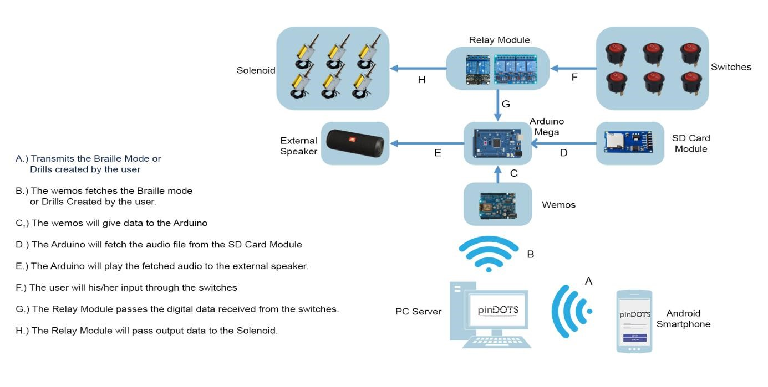said module can read applicable audio files and play them through External Speaker.

*Figure 13*. Block Diagram of the System Setup

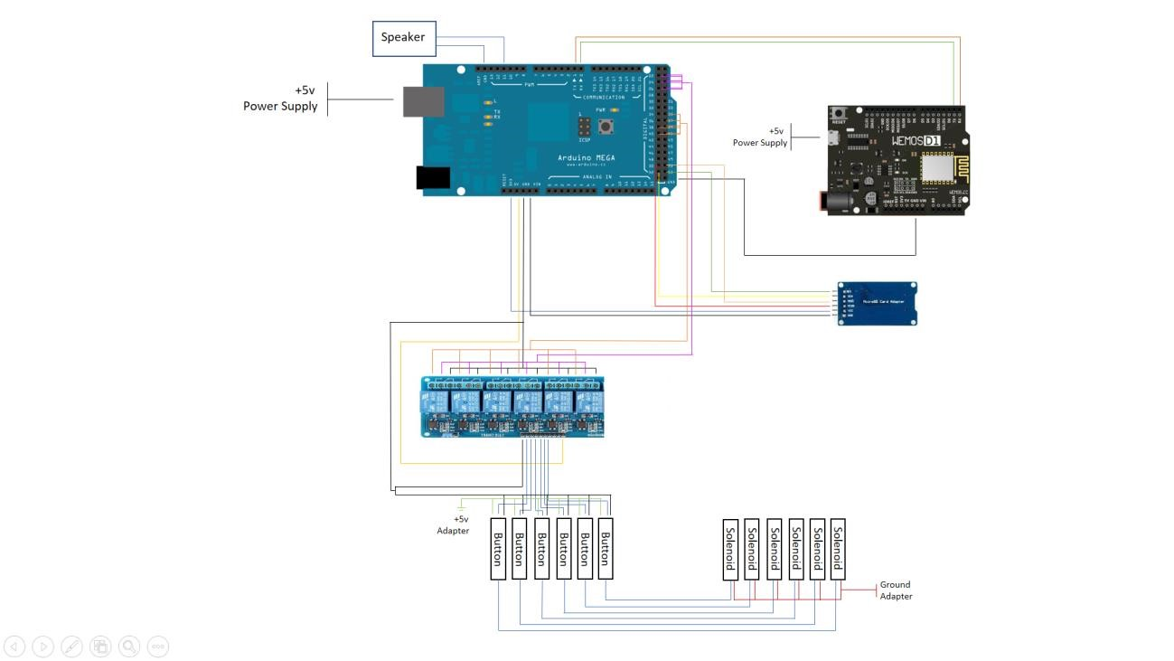

*Figure 14*. Circuit Diagram of the System Setup.

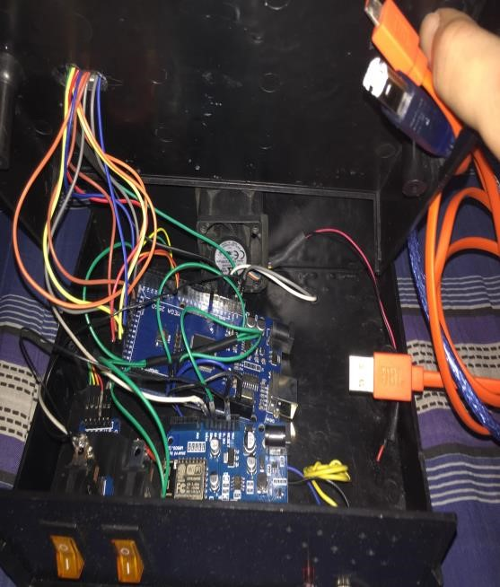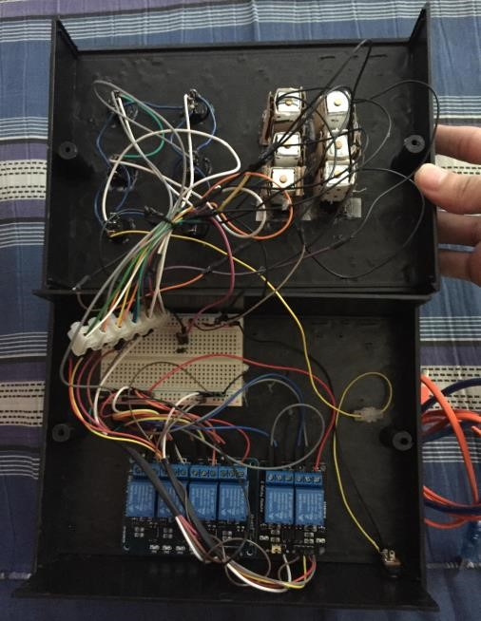

## *Figure 15*. Pictorial Diagram

Figure 16 shows the developed mobile application. The application allows the SPED teachers to create, delete and send drills for students by adding or choosing words in the word bank. Also, the teachers can use the mobile application to choose which mode will visually impaired students be doing. Drills from the application is sent to the device and is heard by the students with the use of the assistive audio system. Lastly, an emulator feature was added in the mobile application wherein the teacher can view and practice the braille notation for alphabet.

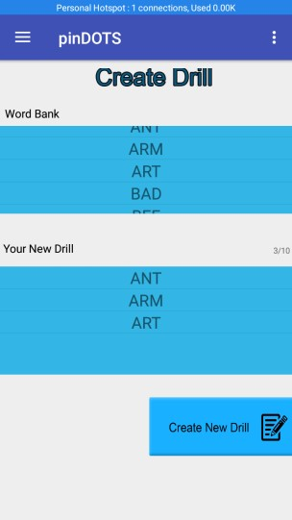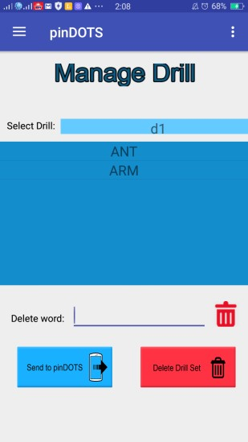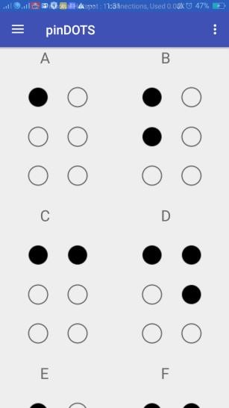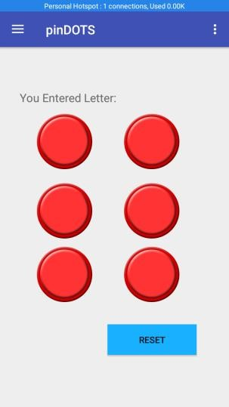

*Figure 16*. PinDOTS Mobile Application

# Summary of Comments of the Respondents

The respondents of the usability tests gave their comments about the hardware device. According to the SPED teacher, the scaling and the sizes of the dots are suited for level 1 or beginners in braille notation. The SPED teacher, who happens to be an expert and a trainer of other SPED teachers emphasized that the tactile materials should be smooth and not pointed. She also emphasized the use of the word “see” rather than “feel” in the assistive audio system. The visually impaired students enjoyed testing the device because it is portable, which is being supported by the assistive audio system that gives instruction on what to do. According to the SPED teacher, the mobile application is a good complement to the braille device and makes the usage of the braille device handier.

# Conclusion

The study was able to meet its general objective by creating a hardware braille device equipped with buttons/switches and braille tactile dots. An assistive six-dot braille cell and six keying buttons/switches for Basic Notation Writing technology on basic braille notation writing was innovated and developed that can be used as a supplementary tool for the visually impaired students and the SPED teachers. The device is also complemented with a mobile android application that contains modules in sending modes and drills that can be used by the visually impaired students. The first objective centred in developing a low-cost braille device that will support the students in learning the basic braille notation was met by creating a braille device incorporated with a low-cost and relatively available materials as seen in a table. There are many available braille writing notation in the market and most of these devices have high cost. The comparison of devices with respect to price can be seen in Table 7 of this chapter. The said table also shows that pinDots has all the core functionalities except one functionality which is having multiple characters. The summary of cost of all materials used in the development of the braille device as seen in Table 6 solidifies that the objective of being a low cost device was met. These concludes that the pinDOTS is practical for SPED centers when it comes to cost and functionalities.

The second objective was to develop a hardware device that is portable, compact, and scaled, incorporated by an assistive audio system and drills. This objective was met by the creating a braille device with scale and size that conforms to the need of beginners in braille writing. This was solidified by strong acceptance of the SPED teacher who happens to be an expert in teaching beginners in braille writing. Also, assistive audio system of the device allows students to follow instructions and even use the braille device with less assistance from the teacher. The results in the UAT in Table 8, referring to the questions for both students and SPED teacher that corresponds to the dots, 6-character cell spacing, size, portability and scale of the braille device, including the improvised materials that was used, has an average rating of 3.78 out of 4, which has an analysis remark of “Agree". This shows that the braille device is suitable for the Visually impaired students who are beginners in basic braille notation.

The third objective was to develop interactive modules that will help the visually impaired students to enhance their kinesthetic and proprioceptive skills. The third objective was met by creating a mobile application which can create and send drills consisted of three-letter words which are passed and retrieved by the device. The teacher can also send the transition of modes to be answered by the visually impaired students which is consists of Tutorial Mode and the Drill Mode. Based on the results of the UAT, questions such as “The braille device is capable of fetching the words to be embossed or engraved”, “The tutorial mode provide proper pressing and keying activity suitable for beginners”, and other questions related to mobile application able to perform the functionalities needed and communicate with the braille device got an average rating of 3.83 which has an “Agree” remarks.

# Recommendations

The device developed has the capability of embossing and engraving the braille dots and is also limited to spelling out three-character words. The mobile application developed along with the hardware is connected to the server via point-to-point connection. To improve the developed braille device, the developers recommend increasing the number of letters that the user will spell out and also, adding of contracted words can be very useful to cater the visually impaired with prior knowledge about braille writing notation. Since the pinDOTS device has the capability to spell out three-letter English words, the developers recommend including numbers in the device to help the students learn mathematics using the braille device.

**Appendices**

# Appendix Title Page

1. Typical Piezo Bimorph Braille Cell 62
2. Different Types of Braille Technologies 62-64
3. Questionnaire 65
4. Tentative Contents of the Drill 66
5. Braille Alphabet 67
6. Tentative Design of Upper Portion of the Device 68
7. Prices of Available Braille Notation Writing 69
8. Project Schedule 70
9. SPED Center in Carmona Elementary High School 71

1. Taptilo: New Smart Device to Teach Braille 71
2. Visually Impaired Students Who Tested PinDOTS

and Image of pinDOTS device. 72

1. Use-Case Diagram 73
2. Braille Grade Level 74
3. Entity Relationship Diagram 74
4. User Acceptance Testing Questions 75-76

**Appendix A**

# Typical Piezo Bimorph Braille Cell

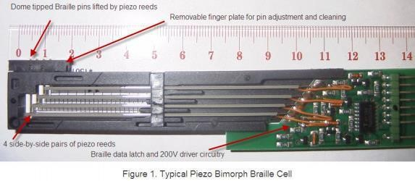

# Appendix B

## **Different Types of Braille Technologies**

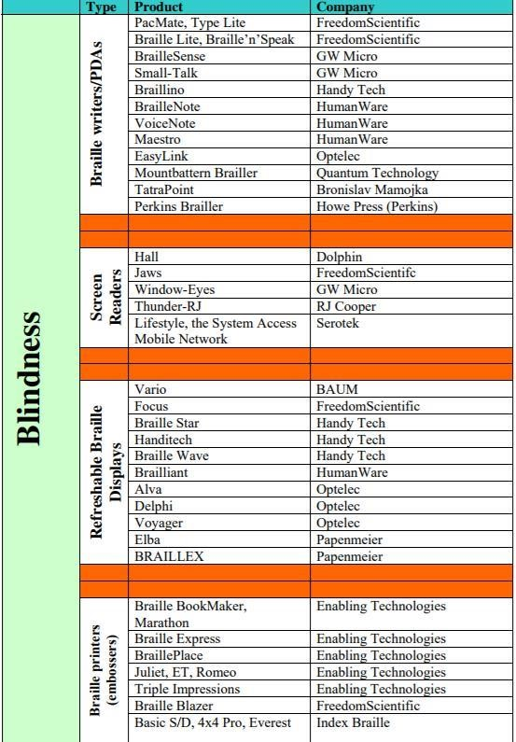

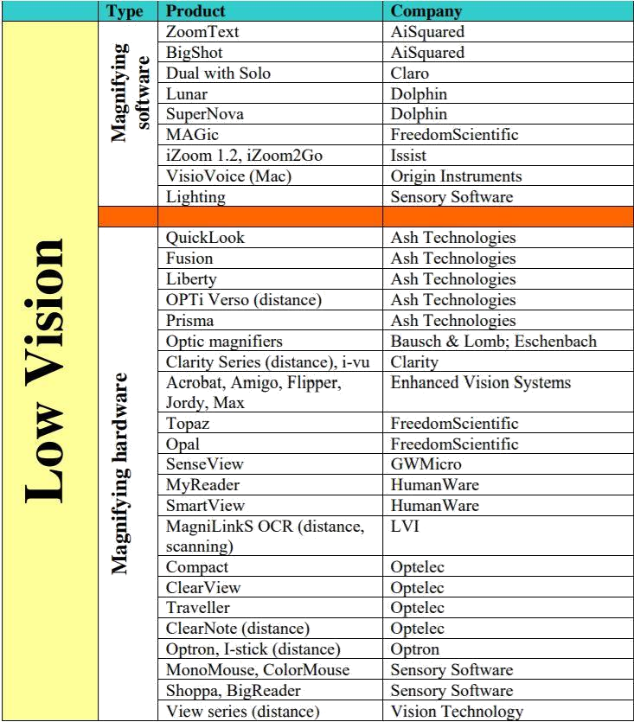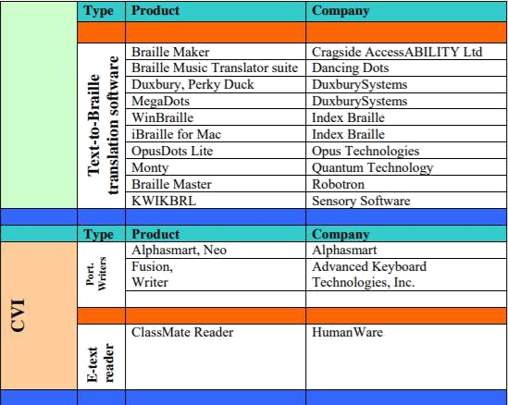

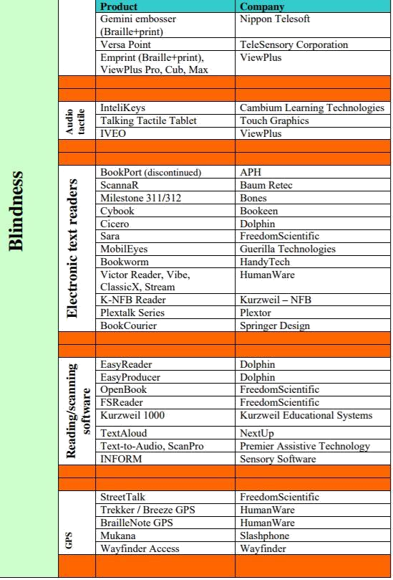

**Appendix C**

# Questionnaire

|  |  |
| --- | --- |
| Questions | Quantity |
| 1.) How many visually impaired students are enrolled? |  |
| 2.) How many teachers are there for visually impaired students? |  |
| 3.) Number of materials to be used by the visually impaired students |  |
| 4.) Cost of current available materials for teaching braille |  |
| 5.) How many sessions per week does the visually impaired students have? |  |
| 6.) How long will it take for the beginners to practice braille? |  |

The research locale has currently ten visually impaired students enrolled in the SPED Center. The visually impaired students has one to two teachers that will help them on learning braille notation.

**Appendix D**

# Tentative Contents of the Drill

There are 63 ways to combine the 6 dots that make the braille cell.

These are utilized for simple reference when discussing which keys to push on the braille writer, electronic notetaker and refreshable braille display or any other assistive technology for visually impaired. Each letter of the letter set has a dot combination that represents the letter. For example, the letter “b” is made by pushing dots 1-2 while the “h” is made by pushing dots 1-2-5. (“Key Points Lesson 1”, n.d.)

Our assistive technology will have pre – defined exercises for the students. An example of a drill can be, pressing of the first dot 3 times. Just like that pressing of all 6 dots 3 times. Different types of drill / exercises from beginner level to intermediate level will help to improve the sensory ability of the students.

**Appendix E**

**Braille Alphabet.**

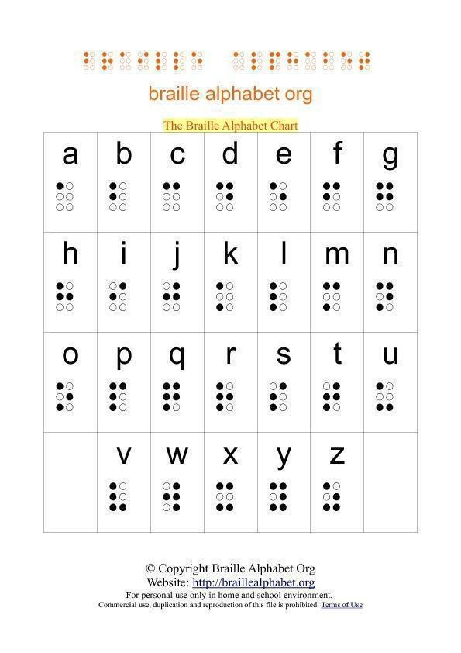

**Appendix F**

# Tentative Design of Upper Portion of the Device

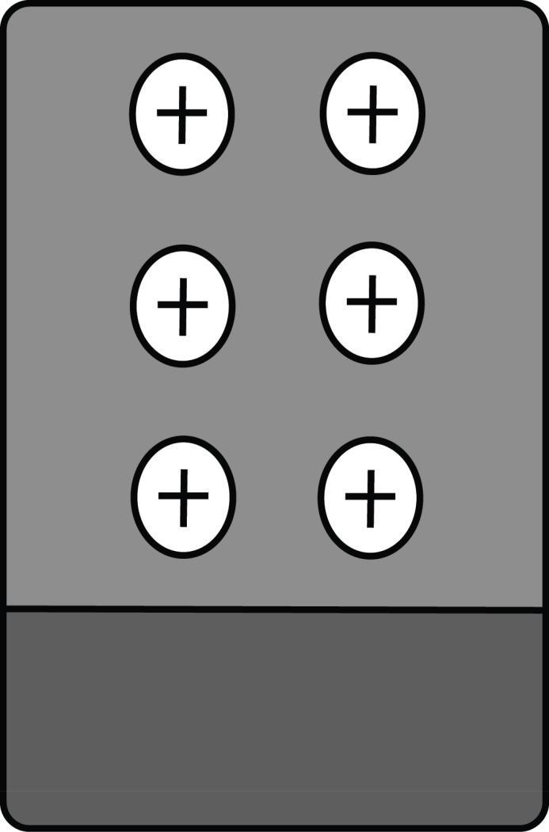

# Appendix G

**Prices of Available Braille Notation Writing**

|  |  |
| --- | --- |
| **Material** | **Price** |
| Standard Slate, Metal | $9.95 |
| [Standard Slate, Plastic](http://www.braillebookstore.com/Standard-Slate,-Plastic.1) | $6.95 |
| Makes 4 Lines, 18 Cells of Jumbo Braille | $9.95 |
| [Clipboard Slate](http://www.braillebookstore.com/Clipboard-Slate.1) | $14.95 |
| [Full-Page Slate, Letter-Size](http://www.braillebookstore.com/Full--Page-Slate,-Letter--Size.1) | $19.95 |
| [Read-and-Write Slate](http://www.braillebookstore.com/Read--and--Write-Slate.1) | $34.95 |
| [Full-Page Slate, A4-Size](http://www.braillebookstore.com/Full--Page-Slate,-A4--Size.1) | $19.95 |
| [Perkins Brailler](http://www.braillebookstore.com/Perkins-Brailler.1) | $789.95 |
| [Refurbished Perkins Brailler](http://www.braillebookstore.com/Refurbished-Perkins-Brailler.1) | $414.95 |
| Electronic Braille Notetakers | Between $1000 and $3,000 with the option of products containing more sophisticated features that can cost up to $15,000. |
| Taptilo: New Smart Device to Teach  Braille | $1,200 |

**Appendix H**

## **Project Schedule**

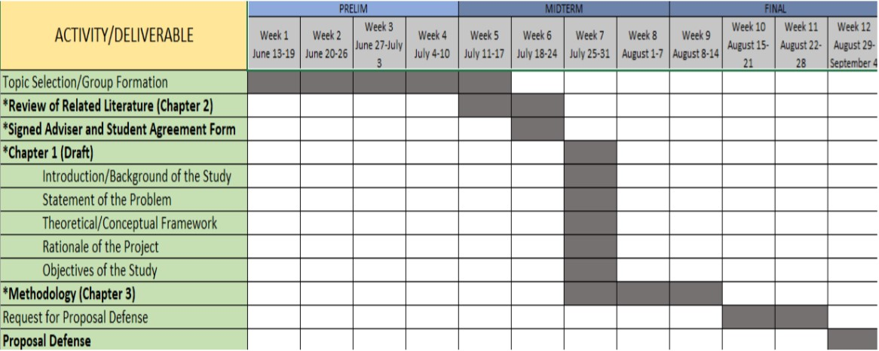

IT Projects 1 Project Schedule

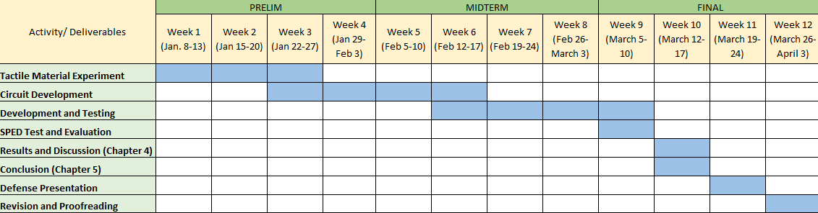

IT Projects 2 Project Schedule

# Appendix I

## **SPED Center in Carmona Elementary High School**

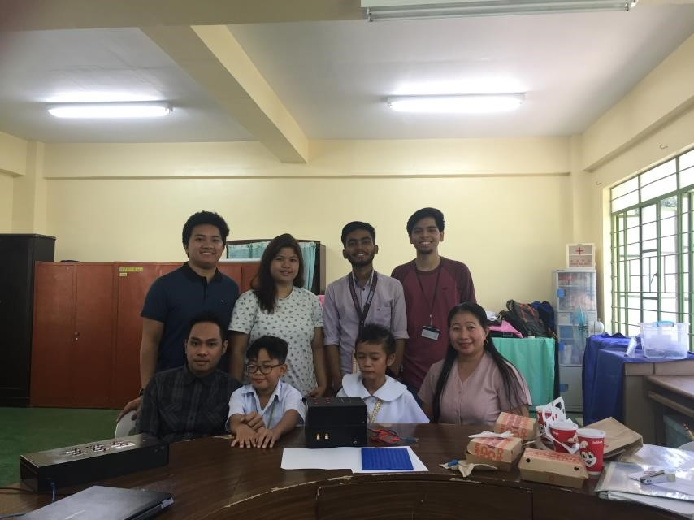

**Appendix J**

# Taptilo: New Smart Device to Teach Braille

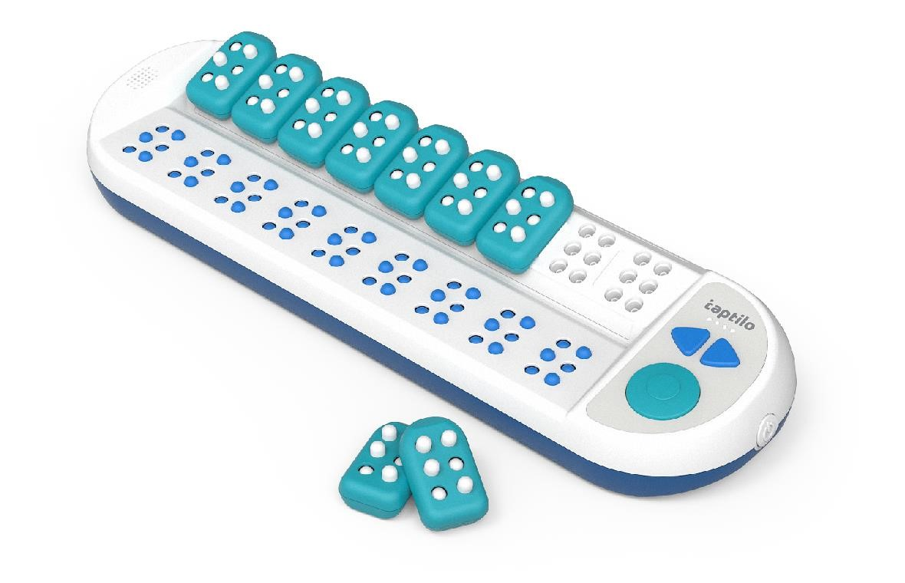

**Appendix K**

# Visually Impaired Students Who Tested PinDOTS and Image of pinDOTS device.

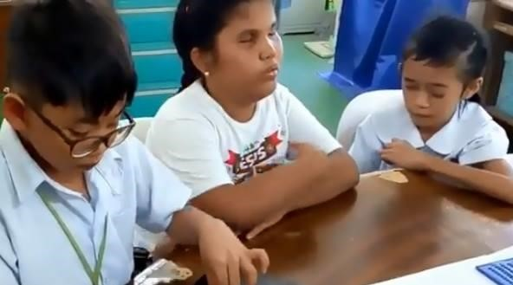

*(From left to right)*

Vince, 8 years old, Level1 braille not yet included in normal classroom. Hanna , 9 years old Level1 to Level 2 braille with inclusion in normal classroom. Joy, 11 years old, done with incubation leading to Level 1 braille.

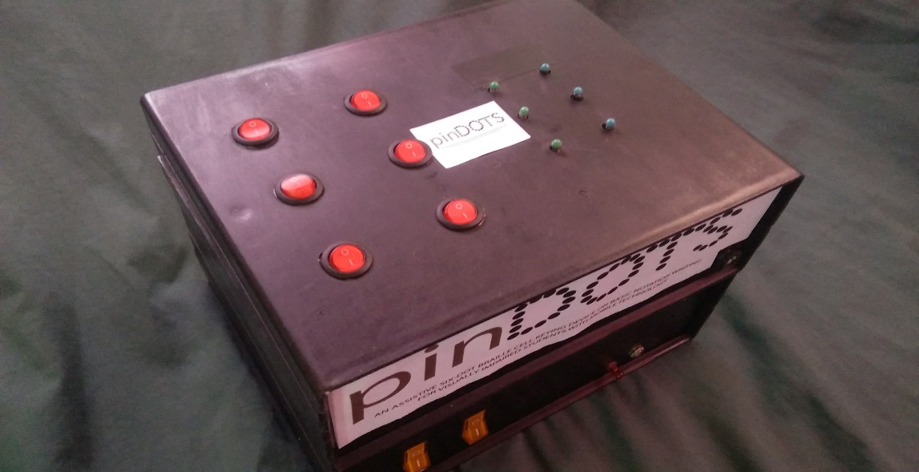

Actual image of pinDOTS device.

**Appendix L**

**Use-Case Diagram**

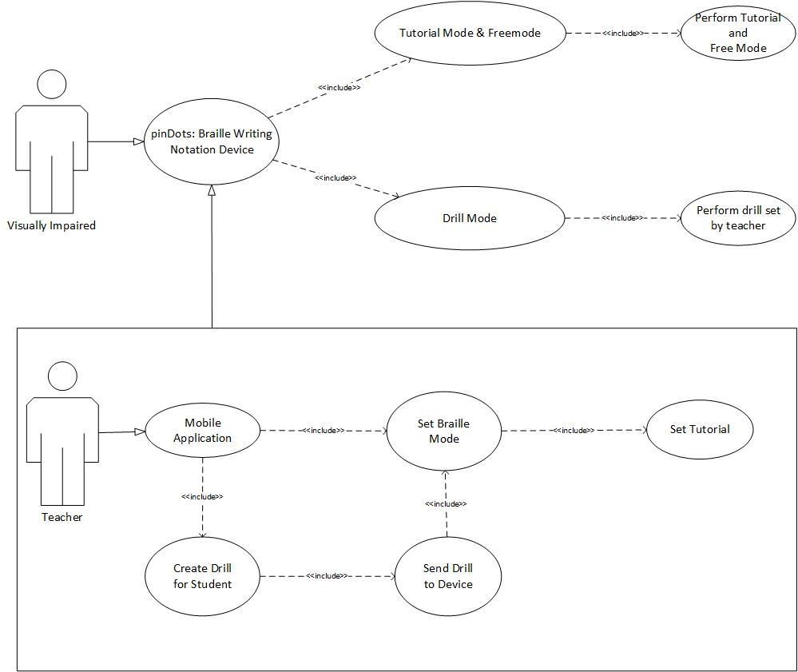

# Appendix M

|  |  |
| --- | --- |
| Braille Grade Level | Description |
| Grade 1 | In the first of the grades of braille, grade 1, each possible arrangement of dots within a cell represents only one letter, number, punctuation sign, or special braille  composition sign - it is a one-to-one  conversion. Individual cells cannot represent words or abbreviations in this grade of braille. |
| Grade 2 | English braille, also known as Grade 2  braille, is the braille alphabet used for  English. It consists of 250 or so letters  (phonograms), numerals, punctuation, formatting marks, contractions, and abbreviations (logograms). |
| Grade 3 | Grade 3 brailleis a variety of nonstandardized systems that include many  additional shorthand-like contractions. They are not used for publication, but by  individuals for their personal convenience. |

**Appendix N**

# Entity Relationship Diagram

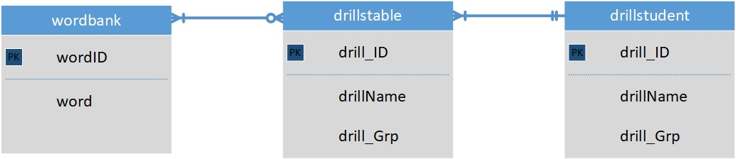

**Appendix O**

# User Acceptance Testing Questions

|  |  |
| --- | --- |
| **Category** | **Questions (Teacher)** |
| Aesthetics | 1. The mobile application's overall design is good and is appropriate for its use. |
| 2. The mobile application's contents are easy to understand. |
| 3. The 6 dot braille single character cell spacing, size, scale of the Braille device is suitable to notation learning |
| 4. The overall design of the braille device fits the requirements in notation learning |
| Usability | 5. The mobile application is easy to navigate. |
| 6. The mobile application is easy to understand at first use. |
| 7. The braille device is portable and stable enough with few required configurations. |
| Usefulness | 8. The audio is helpful in assisting the students in using the braille device. |
| 9. The braille device provides basic braille notations appropriate for beginners. |
| 10. The braille device provides modules that can help in improving the kinesthetic and proprioceptive skills such as keying and pressing skills among students prior to formal braille writing. |
| 11. The tutorial mode and free mode provide proper pressing and keying activity suitable to beginners |
| 12. The braille device is capable of fetching the words to be embossed or engraved. |
| 13. The braille device can be readily used independently as a portable braille |
| 14. The braille device can be readily used in a point to point network environment when sending drills is needed |
| 15. The mobile application is able to change modes wirelessly through mobile application |

|  |  |
| --- | --- |
| **Category** | **Questions(Student)** |
| Aesthetics | 1. I can easily recognize the characters. |
| 2. I can easily adapt to braille dot spacing, size and scale of the  braille device |
| Usability | 3. I can easily use the device at first try. |
| 4. I can identify if the braille dots are embossed or engraved. |
| 5. I can understand the instructions through the audio. |
| Usefulness | 6. I can use the tutorial and free mode by myself with less assistance from my teacher. |
| 7. The device is a good help in practicing my braille notation writing. |
| 8. I can successfully write letters and words through the braille device. |
| 9. I easily familiarized myself with the braille device |
| 10. I can practice my pressing and keying skills through the device |

# References

Brauner, D. (2017, July 25). *Taptilo: New Smart Device to Teach Braille*. Retrieved September 04, 2017, from

http://www.perkinselearning.org/technology/posts/taptilo-newsmart-device-teach-braille

Chakraborty, T., Khan, T. A., & Islam, A. A. (2017). *A Low-Cost Reading and Writing System for Economically Less-Privileged Visually-Impaired People Exploiting Ink-based Braille System*. Retrieved July 7, 2017, from

http://dl.acm.org/citation.cfm?id=3025646

Cook, A. M., & Polgar, J. M. (2014). *Assistive Technologies- E-Book: Principles and Practice*. Retrieved July 10, 2017, from

https://evolve.elsevier.com/cs/product/9780323096317?role=student

Gori, M., Cappagli, G., Tonelli, A., Baud-Bovy, G., & Finocchietti, S. (2016, October). *Devices for visually impaired people: High technological devices with low user acceptance and no adaptability for children*. Retrieved July 14, 2017, from

https://www.ncbi.nlm.nih.gov/pubmed/27484870

Osterberg, G. (2014). *“The Future of Braille” Report Presents Recommendations for Improving Literacy Opportunities*. Retrieved August 5, 2017, from

https://www.loc.gov/item/prn-14-114/future-of-braille-report/2014-07-04/

Runyan, N. H.(n.d.). *EAP Braille Display Needs and Requirements.* Retrieved July 21, 2017, from

https://www.nbp.org/downloads/cbi/EAPBrailleDisplayNeedsandRequirements.pdf

Saxena, N., Watt, J. H., (n.d.). *Authentication Technologies for the Blindor Visually Impaired*. Retrieved July 23, 2017, from

https://www.usenix.org/legacy/event/hotsec09/tech/full_papers/saxena.pdf

Tebo, L.R. (n.d). *A Resource Guide to Assistive Technology for Students with Visual Impairment*. Retrieved August 4, 2017, from

https://www.qiat.org/docs/resourcebank/TEBO_VI_Resource_Guide.pdf

Weisser, R. (n.d.). *A Status Report on the Library for the Blind in the Philippines*. Retrieved July 27, 2017, from

http://www.dinf.ne.jp/doc/english/Us_Eu/conf/z19/z19001/z1900104.html

*Tennessee Council of The Blind*. (2010, August 10). Retrieved August 10, 2017, from http://www.acb.org/tennessee/braille.html

*Accessible and Usable Buildings and Facilities*. (2003). Retrieved July 7, 2017, from

http://academics.triton.edu/faculty/fheitzman/ansi.a117.1.2003.pdf

*DepEd ensures inclusive education for learners with special needs* (2017, February 24). Retrieved July 27, 2017, from

http://www.deped.gov.ph/press-releases/deped-ensures-inclusive-education-learners-special-needs

Functionality Testing | Hardware & Software Tests | NTS. (n.d.). Retrieved September 14, 2017, from

https://www.nts.com/services/testing/hardware-software/functionality/

*"The Future of Braille" Report Presents Recommendations for Improving Literacy Opportunities*. (n.d.). Retrieved July 21, 2017, from

https://www.loc.gov/item/prn-14-114/future-of-braille-report/2014-07-04/

*The Importance of Braille* (2014, November 12). Retrieved July 31, 2017 from

https://www.indexbraille.com/en-us/blog/the-importance-of-braille

*Principles of Assistive Technology for Students with Visual Impairments.* (n.d.). Retrieved July 21, 2017, from

http://www.tsbvi.edu/general/1076-principles-of-assistive-technology-for-studentswith-visual-impairments

*Size and Spacing of Braille Characters* (n.d). Retrieved July 31, 2017, from

http://www.brailleauthority.org/sizespacingofbraille/sizespacingofbraille.pdf

*Standard dimensions for the UK Braille Cell* (2017, April)*.* Retrieved July 23, 2017 from

https://www.ukaaf.org/wp-content/uploads/BrailleStandardDimensionsFinal.pdf

*US4880384A - Braille teaching apparatus*. (n.d.). Retrieved July 21, 2017, from

https://patents.google.com/patent/US4880384

*What is Arduino?* (n.d.). Retrieved August 4, 2017, from

https://www.arduino.cc/en/Guide/Introduction

|  |  |  |
| --- | --- | --- |
|  | **List of Figures** |  |
| **Figure** | **Description** | **Page** |
| Figure 1 | Conceptual Framework of the System | 15 |
| Figure 2 | Conceptual Model of the System | 17 |
| Figure 3 | Braille Alphabet | 25 |
| Figure 4 | ITS components and their interactions | 34 |
| Figure 5 | Nurun-Base Methodology for IoT | 43 |
| Figure 6 | Tabular representation of materials used with corresponding prices | 53 |
| Figure 7 | Visually impaired students Aesthetics  Survey Results | 55 |
| Figure 8 | SPED Teachers Aesthetics Survey  Results | 56 |
| Figure 9 | Visually Impaired Students Usability Survey Results | 57 |
| Figure 10 | SPED Teacher Usability Survey Results | 57 |
| Figure 11 | Visually impaired students Usefulness  Survey Results | 58 |
| Figure 12 | SPED Teachers Usefulness Survey  Results | 61 |
| Figure 13 | User Acceptance Testing Result Summary | 62 |
| Figure 14 | Block Diagram of the System Setup | 66 |
| Figure 15 | Circuit Diagram of the System Setup | 67 |
| Figure 16 | Pictorial Diagram | 67 |
| Figure 17 | PinDOTS Mobile Application | 68 |

**List of Tables**

|  |  |  |
| --- | --- | --- |
| **Table** | **Description** | **Page** |
| Table 1 | Functionality test of the Audio System modules | 39 |
| Table 2 | Functionality test of the Wemos modules | 40 |
| Table 3 | Functionality test of the Mobile Application | 41 |
| Table 4 | Functionality test of the braille dots modules | 42 |
| Table 5 | Functionality test of the braille buttons modules | 43 |
| Table 6 | Tabular representation of materials used with corresponding prices | 44 |
| Table 7 | Comparison of core functionalities of related braille writing device | 45 |
| Table 8 | User Acceptance Testing Result Summary | 52-55 |